Ephemeral stream contributions to United States drainage networks

Craig B Brinkerhoff1,✉, Colin J Gleason1, Mathew J Kotchen2, Doug Kysar3, and Peter A Raymond2

1 Department of Civil & Environmental Engineering, University of Massachusetts; Amherst, MA  
2 School of the Environment, Yale University; New Haven, CT  
3 Yale Law School, Yale University, New Haven; CT

✉ Correspondence: [Craig B Brinkerhoff <[cbrinkerhoff@umass.edu](mailto:cbrinkerhoff@umass.edu)>](mailto:cbrinkerhoff@umass.edu)

## One-Sentence Summary

Ephemeral streams contribute a significant portion of freshwater to drainage networks and directly implicate United States water quality.

## Abstract

Ephemeral streams flow only in direct response to precipitation and are under consideration for removal from Clean Water Act (CWA) regulation (*1*). Understanding of their influence on water quality is underdeveloped, and therefore little is known about what these CWA changes mean for U.S. water quality. Here, we model ephemeral stream contributions to the entire contiguous U.S. network of 20,708,897 rivers, lakes, reservoirs, canals, and ditches, finding that they contribute 1,221 $±$ 168 $km^{3}/yr$, or 14 $±$ 2% of the total runoff, into the CONUS drainage network despite only flowing on average 34 $±$ 13 days a year. The ephemeral terrestrial-aquatic connection is therefore a substantial pathway through which pollution may enter the downstream perennial drainage network and degrade water quality under the proposed changes to CWA jurisdiction.

## Main Text

Streams transport nutrients, sediments, pollutants, and other constituents from the land surface to rivers, lakes, reservoirs, and the oceans (*2*–*5*), influencing all downstream water quality (*6*–*8*). The most upland streams (e.g. headwaters) are often ‘ephemeral’ streams, which flow only in direct response to precipitation and are disconnected from groundwater (unlike like larger downstream rivers). Recently, the United States Navigable Waters Protection Rule (NWPR) enacted changes to what constitutes the ‘Waters of the United States’ (WOTUS), removing CWA jurisdiction from ephemeral streams (along with ‘disconnected wetlands’). The NWPR enables the destruction, filling in, and/or discharge of point-source pollution into the U.S. ephemeral stream network (*1*, *9*). The operational definition of WOTUS is a contentious topic and has received considerable attention from environmental groups, farm lobbying groups, and politicians since the CWA was enacted in 1972 (*6*, *9*). The NWPR’s implementation is currently on hold as it sits before the U.S. Supreme Court.

Non-perennial streams (which include ephemeral and intermittently dry rivers) account for over half of the global river network (*10*). While much recent work has developed classification models to identify non-perennial streams (*10*–*14*), only one paper focused specifically on ephemeral streams (*14*) and all recent work stopped short of assessing the hydrological and biogeochemical contributions of ephemeral streams to the overall drainage network at broad sptial scales. Thus, we presently can neither quantify the significance of ephemeral streams to watershed hydrology nor the potential water quality ramifications of the NWPR.

In that context, here we use a simple geomorphic model to identify ephemeral streams by comparing long-term water table depths with drainage network presence in 20,708,897 discrete streams, rivers, lakes, reservoirs, canals, and ditches across the contiguous United States (CONUS). We then perform a first-order survey of American ephemeral streams along three axes that broadly capture potential for water quality degradation via the NWPR: 1) flow contribution/volume, 2) landscape contribution/drainage area, and 2) flow frequency (*15*). For 1) and 2), we use groundwater (*16*), discharge (*17*), runoff (*18*) and precipitation (*19*) models and data to quantify how often and the volume of water transported by ephemeral streams. For 3), we use land cover data (*20*) to identify riparian land uses along ephemeral streams. Finally, we identify basins where all three axes combine to create potentially significant water quality degradation if the NWPR is enacted. We define and discuss the four metrics that make up our assessment (equations S1-S4), validate individual model components (Figs. S1-S5), and test parameter sensitivity when necessary (Figs. S6-S9) (*15*).

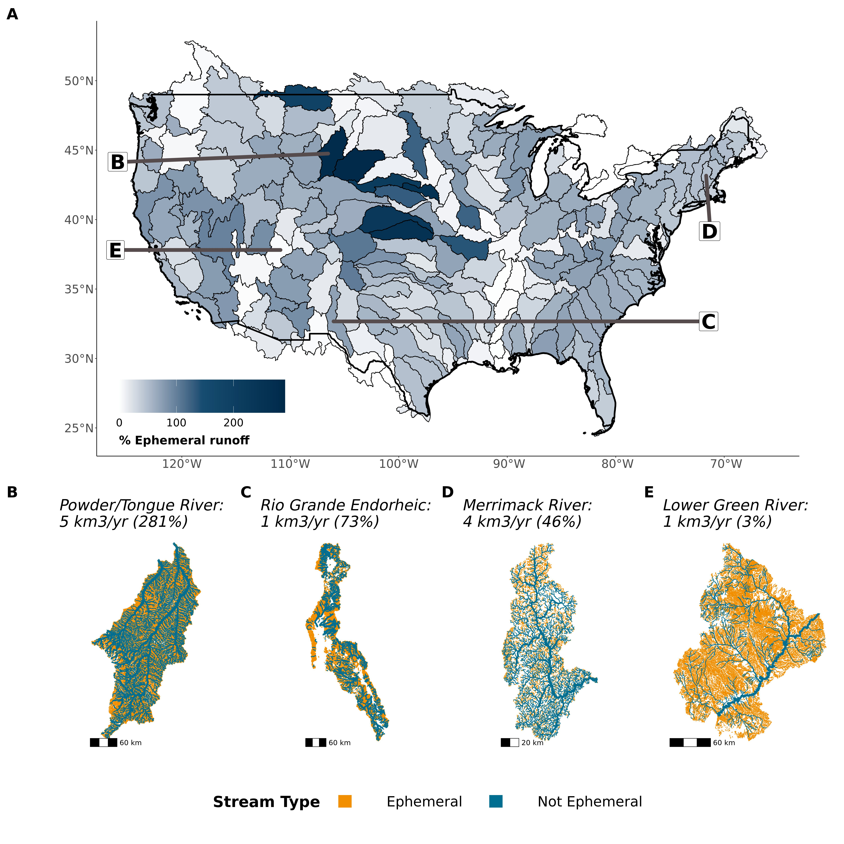

Fig. 1: Assessing ephemeral streams by their runoff contribution to drainage networks. (A) Contiguous United States map of ephemeral streams’ relative, mean-annual runoff (equation S1). (B-E) Drainage network maps and runoff contributions for four representative scenarios: (B) semi-arid basin with net losing perennial streams, (C) endorheic desert basin, (D) steep humid basin, and (E) arid basin with a dominant perennial river. Reach size corresponds to logarithmic bins of streamflow and is relative to map scale. Relative ephemeral runoff contributions arise from the complex interplay of topography, climate, and drainage network structure and can exceed 100% in net losing basins (Fig. S10).

Ephemeral streams contribute 1,221 $±$ 168 $km^{3}/yr$ of runoff into the CONUS drainage network. This flux is nearly identical to average annual North American continental freshwater discharge to the Arctic Ocean: 1,181 $km^{3}/yr$ (*21*) and is 14 $±$ 2% of the total annual runoff into the CONUS drainage network (Figs. 1a, S10). Relative ephemeral contributions vary substantially (Fig 1a). The average eastern ephemeral relative contribution is 40% versus 64% in the Southwest and Great Plains. This is due to the wetter conditions in the East contributing greater total runoff to ephemeral streams. At the basin-scale, those dominated by a single large perennial river (e.g. Mississippi, Missouri, Colorado, Rio Grande, Colombia, Ohio rivers) show relatively little ephemeral influence (Figs. 1a, S10). Ephemeral contributions can exceed 100% in basins with widespread losing conditions in their non-ephemeral streams, where there is a net loss of discharge to the atmosphere or groundwater. This occurs in the Ogallala Aquifer where widespread losing conditions prevail from groundwater pumping and there is a potentially significant loss of non-ephemeral streamflow to groundwater (Fig. S11) (*22*, *23*). We note that ephemeral streams will only become more frequent as groundwater pumping intensifies and water tables continue to drop (*24*, *25*).

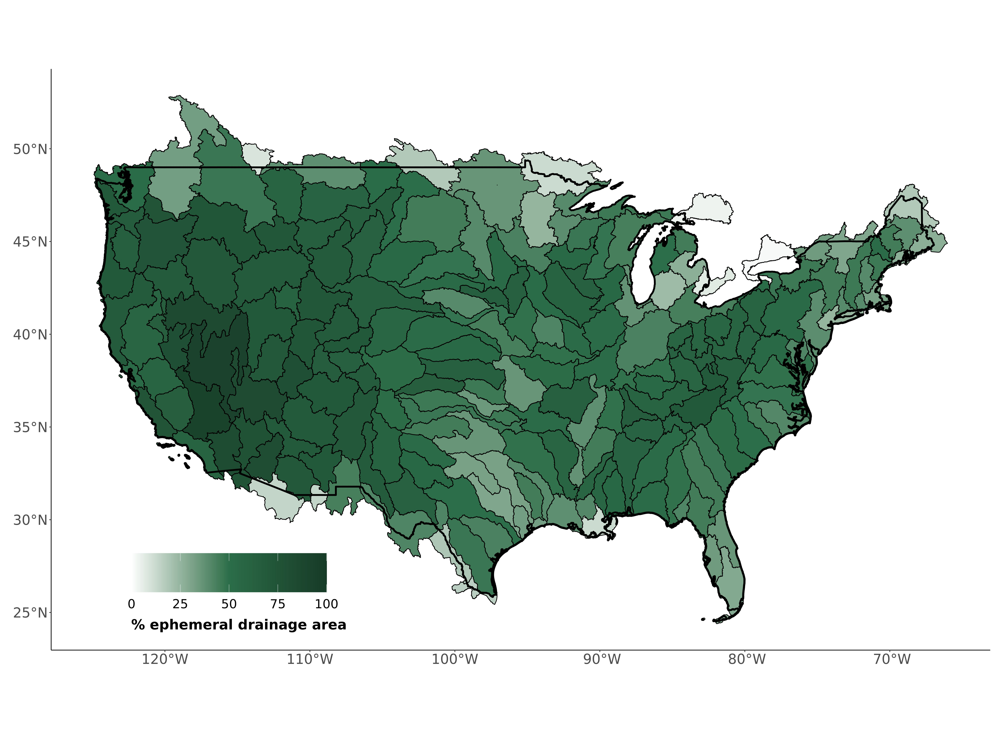

Fig. 2: Assessing ephemeral streams by landscape contribtuion. Contiguous United States map of the basin fraction (% drainage area) that is ephemeral (equation S2).

Ephemeral streams drain, on average, 51% of a basin, and this is realtively consistent across CONUS.

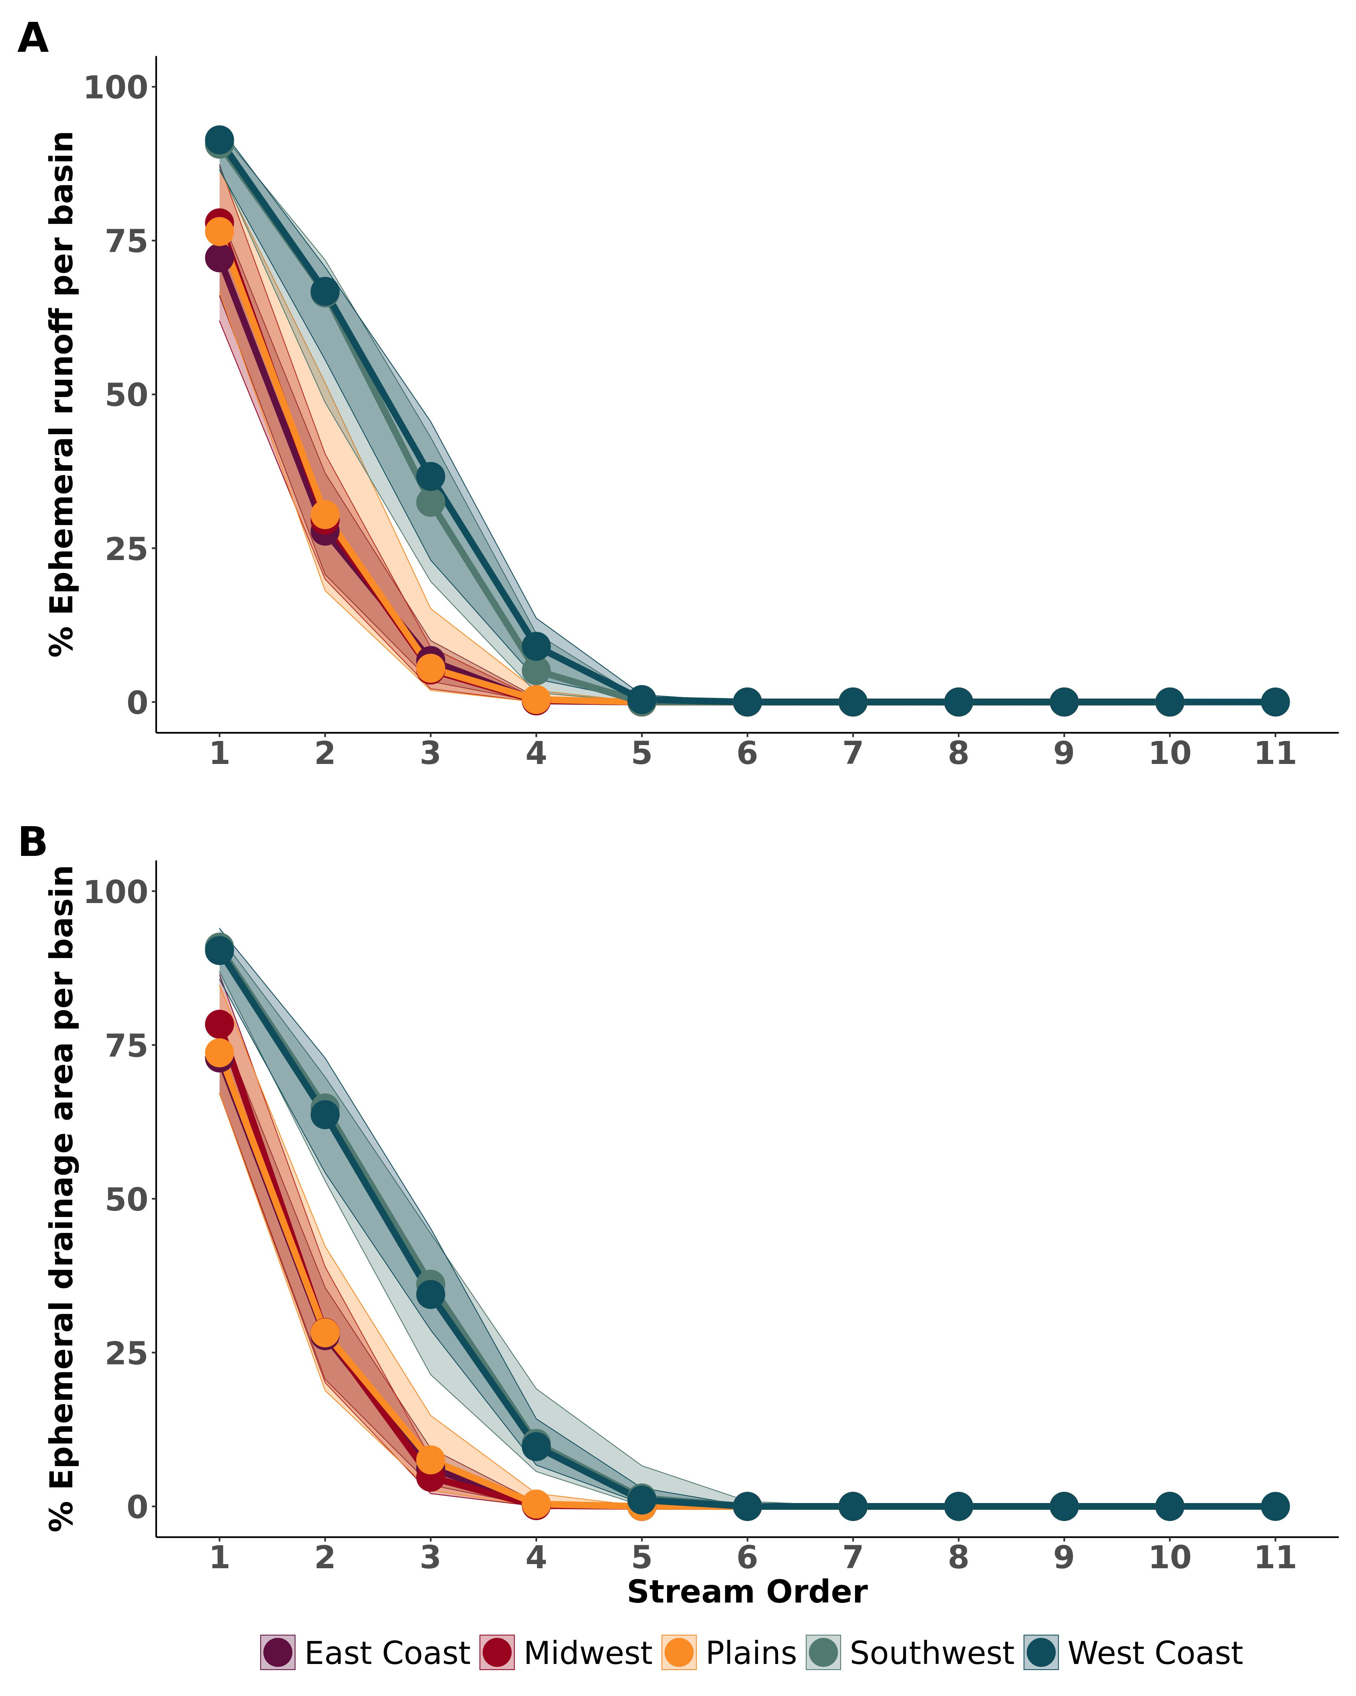

Fig. 3: Assessing ephemeral streams in the context of dilution. (A) % ephemeral runoff contribution per basin per order. Plotted are the medians (points) and inter-quartile ranges (ribbons) binned region. (B) Same for % ephemeral drainage area. Ephemeral runoff importance is uniformally greatest in the smallest streams and is continually diluted by non-ephemeral discharge untl the 5th order, when the ephemeral contribution is functionally gone. Even in networks dominated by a large perennial river, ephemeral streams still comprise the majority of runoff contributed to the drainage network.

Ephemeral contributions are greatest in the smallest streams. Across all basins and regions, ephemeral contributions dominate the smallest stream orders regardless of the presence of a large downstream perennial river (Fig. 3). The ephemeral influence steadily decreases with stream order due to dilution, until it disappears in approximately the 5th order. Due to the fractal nature of streams [], this means that the vast majority of rivers, lakes, reservoirs, and streams have a significant ephemeral contribution to their runoff.

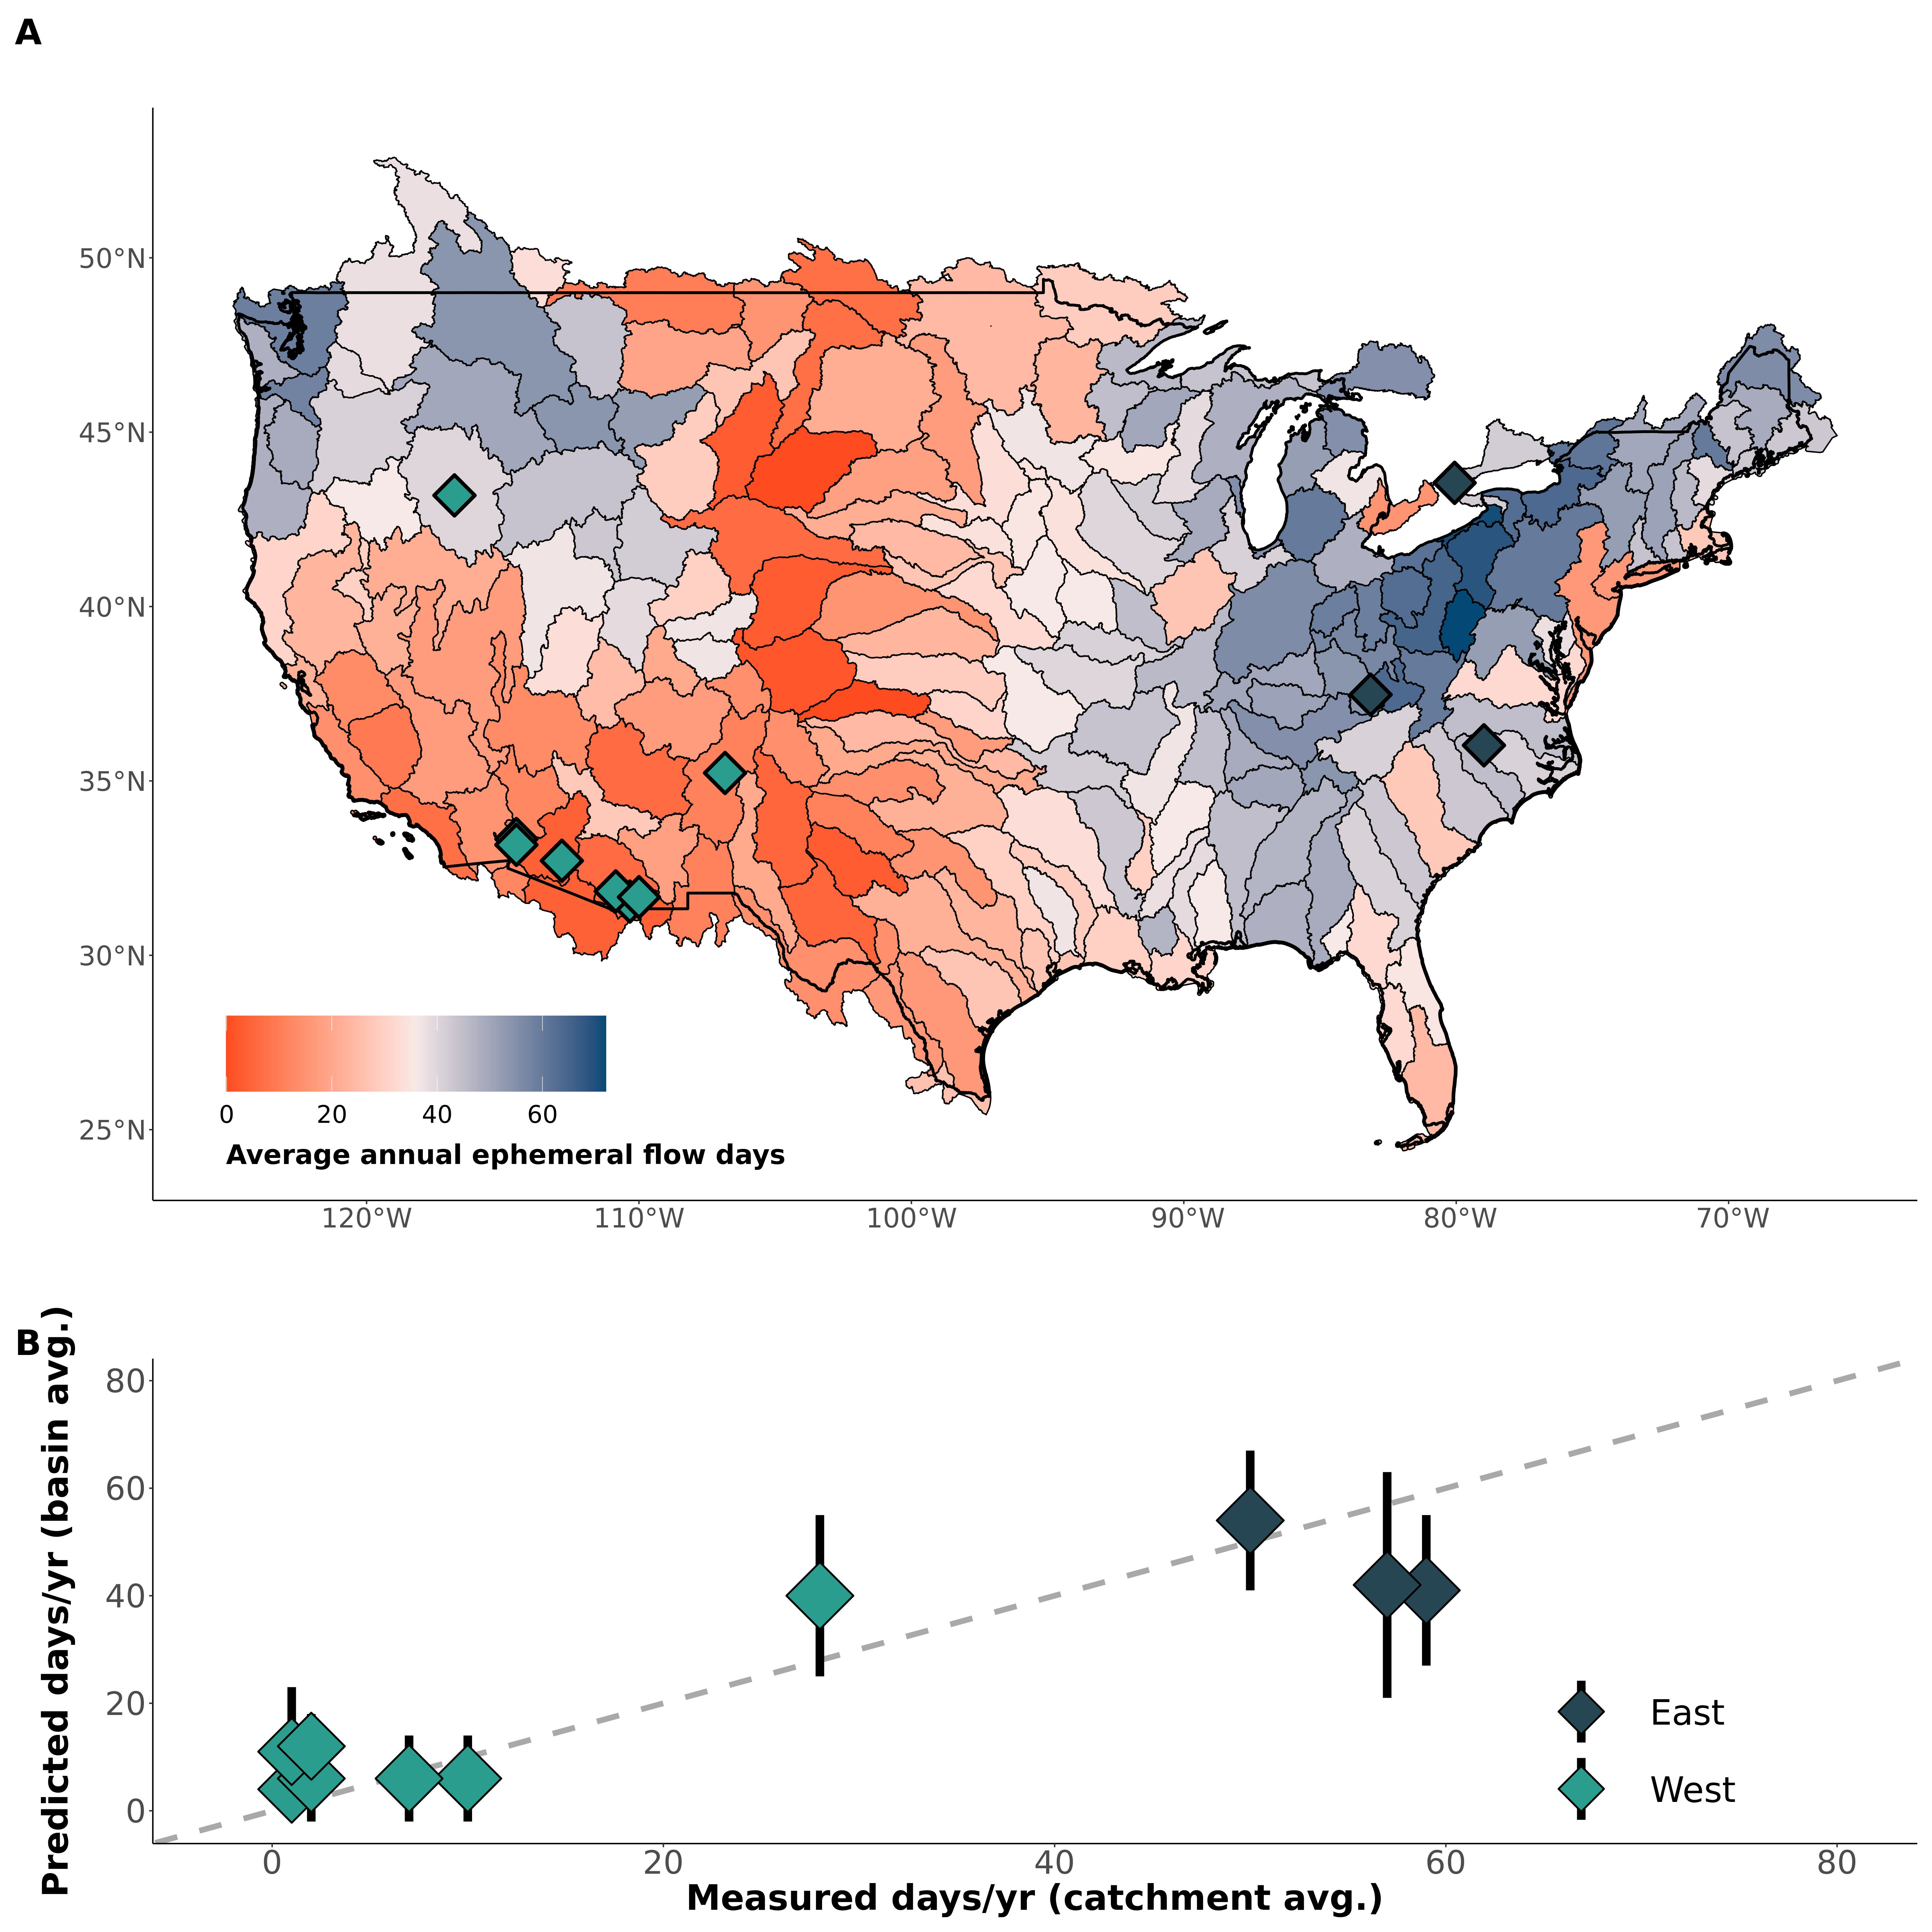

Fig. 4: Assessing ephemeral streams by how frequently they flow. (A) Contiguous United States map of the average number of days that ephemeral streams flow per year (equation S2), with points indicating approximate locations of field verification data. (B) Verification of model results with field data. Black bars represent 1 $σ$ uncertainty (*15*). Ephemeral flow frequency manifests as a delicate balance between hydro-climatology controlling the size and occurrence of runoff events and geomorphology controlling the amount of accumulated runoff needed to produce streamflow.

The significance of the ephemeral contribution (Figs. 1-3) is underpinned by how infrequently they flow (Fig. 4a). Ephemeral streams flow no more than 72 $±$ 21 days in an average year, with a mean of 34 $±$ 13 days. Ephemeral flow frequency largely follows topographic and climatic patterns: in the Great Plains and Great Basin they only flow 24 days a year on average, while they flow 40 days on average in eastern Basins. In the southwest deserts, this drops to an average of 13 days a year. Our simple, completely uncalibrated model uses only a precipitation model, runoff data, and geomorphic scaling theory, yet it reasonably matches independent in situ measurements of catchment-averaged, ephemeral flow frequency (Fig. 2b) (*15*). *something connecting back to flow frequency impacts water volumes*.

Overall, our results (Figs. 1-4) illuminate a terrestrial-aquatic connection that facilitates the introduction of pollution to the CONUS drainage network (note that while the *CWA* applies only to point-source loadings, our results broadly suggest widespread implications for diffuse pollution too. We focus specifically on the volume of water contributed by the CONUS ephemeral network, which will likely lead to large, unregulated pollution discharge if the *NWPR* is enacted. However, the impact of ephemeral streams on CONUS water quality is likely even greater, as some chemicals remain impactful even after massive amounts of dilution [*CITE*]. This means that basins with purportedly small ephemeral contributions (e.g. the lower Colorado basins- Figs. 1-3) could still contribute to widespread water quality degradation.

**Have room here for a final paragraph on implications, regulations, policy, etc. Below is some scattered language I thought of but am not wedded to** Our report suggests that the ephemeral contribution to fluvial hydrology, biogeochemistry, and overall water quality is greater than previously thought (Figs. 1-3). While ephemeral streams often dominate desert basins, they also exist ubiquitously along the landscape continuum in wetter systems and thus NWPR impacts are likely to be felt across CONUS (Fig. 4). Removing CWA jurisdiction from 14 $±$ 2% of CONUS discharge contributions would be a significant blow to freshwater conservation.

## References

references bust be moved here manually for Science submission

## Acknowledgements

We thank Dr. Ying Fan Reinfelder, the USGS, and the EPA for making their data and/or models freely available. All modeling was performed on the Unity cluster at the Massachusetts Green High Performance Computing Center (MGHPCC).

## Funding

AmI missing anything? Craig Brinkerhoff, Peter Raymond, and Colin Gleason were supported by *WROL*. Craig Brinkerhoff was also supported by *FINESST*.

## Author Contributions

* Conceptualization: PAR, CBB, MJK, DK
* Methodology: CBB, PAR, CJG
* Investigation: CBB, PAR, CJG, MJK, DK
* Visualization: CBB
* Supervision: PAR
* Writing- original draft: CBB
* Writing- review & editing: CBB, CJG, PAR, MJK, DK

## Competing interests

Authors declare that they have no competing interests.

## Data and materials availability

**blah blah blah**.

## Supplementary Materials

* Materials and Methods
* Figs. S1 to S11
* Tables S1 to S5
* References 26-54



# Supplementary Materials for

Ephemeral stream contributions to United States drainage networks

C.B. Brinkerhoff, C.J. Gleason, M.J. Kotchen, D. Kysar, P.A. Raymond

Correspondence to [cbrinkerhoff@umass.edu](mailto:cbrinkerhoff@umass.edu)

## This PDF file includes:

* Materials and Methods
* Figs. S1 to S11
* Tables S1 to S5

## Materials and Methods

To perform a first continental-scale assessment of ephemeral stream contributions to CONUS drainage networks, we use 3 relative metrics (axes) to frame our exploration: ephemeral flow contribution/volume, ephemeral flow frequency, and ephemeral pollution loading potential. We also create a cumulative metric (‘NWPR impact index’) that assess all three simultaneously (section 2). All modeling and analysis was performed on the Unity Cluster at the Massachusetts Green High Performance Computing Center (MGHPCC) using publicly available datasets, models, and entirely free and open-source geoprocessing tools in the R programming language. All data and models used in this analysis are described in Table S1.

### 1 Drainage network framework

#### 1.1 Overview

CONUS drainage network hydrography is defined by the United States Geological Survey (USGS) National Hydrography Dataset High-Resolution (NHD-HR) built at 1:24,000 map scale (*17*). This is updated and higher-resolution version of the commonly used National Hydrography Dataset and is still in development by the USGS. We use the data publicly available as of Spring 2022. This is the highest resolution hydrography data available and is often treated as a gold-standard to benchmark hydrography models against. The NHD-HR is discretized into ‘reaches’, which correspond to mass-conserved segments of rivers, streams, ditches, canals, lakes, and reservoirs. The NHD-HR uses artificial flowpaths to maintain network topology through lakes and reservoirs, and here we use a previous framework to incorporate discretized lake/reservoir bathymetry into our model that accounts for complex lake/reservoirs with multiple river inputs (*26*). The NHD-HR also uses nested drainage basins across 12 scales. We run our model at the 4th level and our mapping validation at the 2nd level. This was done based on data resolution, data availability across the United States, and ease of interpretation.

As will all human-built products, NHD-HR data quality varies across CONUS. We identified significantly higher drainage densities in the NHD-HR for the state of Indiana (often 1-2x the stream orders as other portions of a given basin in adjacent U.S. states). For these basins, we manually removed the lowest 1 or two stream orders within the Indiana portions of these basins, until the whole-basin drainage density was visually consistent. We also removed all divergent reaches, i.e. minor flowpaths that diverge from the main downstream path of flow. We did not remove the rest of the flowpath downstream of a divergent reach if there was another, non-divergent source that joined and made the path no longer divergent. Divergent channels are generally alternative flowpaths for the same rivers, and so we remove them to avoid double-counting reaches in the same, multi-channel river.

#### 1.2 Discharge model

Each reach is associated with a mean annual discharge $\overset{‾}{Q}$ as modeled by the USGS (*17*). These are obtained through a runoff routing scheme that additionally accounts for evapotranspirative losses (i.e. losing streams). The USGS validated this model using mean annual streamflow for 1970-2000. To confirm model performance for more recent years, we extend the validation to 1970-2018 using all USGS streamguages with sufficient data (Fig. S4- 4,044 gauges). The discharge model is validated in Fig. S4, where the model robustly captures mean annual discharges for 1970-2018 and performs comparably to a similar global discharge model used to map global river intermittentcy (*10*).

#### 1.3 Hydraulic Geometry

We use hydraulic geometry scaling to obtain broad estimates of mean annual river, lake, and reservoir depth that are needed to assess ephemerality (Section 3). For rivers, canals, and ditches we used the relation from (*27*), who fit an equation of the form $H=c{\overset{‾}{Q}}^{f}$ on over 500,000 USGS in situ measurements of river channel depth *H* and discharge *Q*. For lakes and reservoirs, we mass-conservation to obtain average depths from lake/reservoir volume (*Vol*) and surface area *SA*. *Vol* was scaled using an existing equation of the form $Vol=a{\left(SA\right)}^{1.2}$ (*28*), developed using the Hurst coefficient for self-affine surfaces and existing datasets.

#### 1.4 Field data on stream ephemerality

We use a dataset of field assessments of ‘stream ephemerality’ to validate our stream classification model. This dataset comes from three sources: a) EPA WOTUS jurisdictional determinations, b) USGS streamgauges, and c) field assessments of New England streams. These are described next.

The EPA Jurisdictional Determinations dataset (*29*) consists of site assessments (as of 06/20/2022 when downloaded) for WOTUS status made at the landowners request, where status was determined under the at-the-time WOTUS definitions. We filter this dataset to include only determinations made under the NWPR after it was enacted in 2020, which includes an explicit category for ephemeral streams to exclude them from WOTUS. This amounts to over 60,000 distinct jurisdictional determinations (including multiple determinations in the same reach, over space and time) and forms the bulk of our dataset. To make the dataset copacetic with our model, we remove data not associated with surface water features directly connected to the drainage network: adjacent/riparian wetlands, drylands, uplands, upland or non-adjacent wetlands/ponds/depressions, croplands, wastewater plants, and groundwater. We retained all other determinations that are directly connected to the drainage network (rivers, lakes, reservoirs, canals, ditches, stormwater control features, and artificial surface water features) and recast all determinations as ephemeral or non-ephemeral.

We supplement the Jurisdictional Determinations dataset with the USGS streamgauge network. Because the EPA Jurisdictional Determinations are done on a voluntary basis at the landowner’s request, it is biased towards surface waters whose WOTUS status is difficult to determine without a proper field assessment and thus rarely includes larger (generally perennial) rivers. To make sure we are also correctly classifying these rivers, we use gauged rivers (section 1.2). All gauged rivers that, on average, are flowing 95% of the year (for 1970-2018) are assumed to be non-ephemeral, and are added to the dataset as such.

Finally, we assess stream ephemerality in the northeastern U.S. ourselves as our filtered and cleaned dataset includes no ephemeral reaches in this region. We follow the ‘expert protocol’ used by North Carolina’s department of Water Quality for assessing stream ephemerality (*30*). This protocol uses geomorphic, hydrological, and biotic indicators of seasonally and/or permanently high water tables to assess stream permanence. We use our local knowledge to identify streams we thought are likely to be ephemeral, verify they are present in the hydrography (but do not look at the model result a priori to avoid biasing our assessments) and assess the channels following the protocol. Classification results are in Table S2 for five sites. All streams are assessed over 48 hours from the most recent rain event to avoid the influence of delayed runoff in the channel that might be mistaken for baseflow. Note that we do not perform full soil assessments nor species counts as the protocol technically specifies, but instead perform rapid visual assessments that favor speed of classification over thoroughness. Per the protocol, none of these channels are close enough to being classified as intermittent (Table S2) that we feel confident our rapid assessments are sufficient. While we only assessed five ephemeral rivers, they provide at least some validation data in the northeastern U.S. Further, this sample size is on par with some other regions’ number of ephemeral validation sites.

We join the three datasets to the hydrographic framework by snapping each field assessment to the nearest reach. Despite it’s high resolution, the NHD-HR does not contain every stream in the U.S. and many of the field sites are not expected to be associated with a reach. So, we use a reasonable threshold for the maximum allowable snapping distance between the field site and the reach. Too small a threshold and we miss field sites that have locational error in their geographic coordinates. Too large a threshold and field sites are associated with the wrong river and produce an unrealistic landscape patterns of ephemerality. Sensitivity to this snapping threshold is explained in Section 3.3. Ultimately, we settle on a threshold of 10m. After snapping, we assign the most frequently occurring field assessment along the reach as its ‘true assessment of ephemerality’. Ultimately, we have 7,892 field assessments of reach ephemerality to validate our model. Figure S1b maps the regional number of these data for all of CONUS.

### 2 Metric definitions

Ephemeral flow contribution $Eph_{vol}$ is the mean annual volume of water contributed to drainage networks by ephemeral streams, relative to the whole-network contribution (equation S1). $Q_{L_{e}}$ is the volumetric stream runoff added to the drainage network by each ephemeral stream/catchment *e* (a subset of all reaches *k*). Runoff accumulates as discharge in drainage networks, so $Eph_{vol}$ in a perfectly closed and gaining watershed would equivalently represent the fraction of total watershed discharge that is “ephemerally sourced”. Many of our basins have multiple outlets and disconnected streams, so equation S1 more realistically reflects the runoff *into* the drainage network, rather than the discharge *from* the drainage network. Equation S1 is mapped in Fig. 1a.

$$Eph_{vol}=\frac{\sum_{e=1}^{E}{Q_{L_{e}}}}{\sum_{k=1}^{K}{Q_{L}}}\left(S1\right)$$

Ephemeral flow frequency $Eph_{freq}$] is the fraction of an average year (in days) that ephemeral streams are flowing. We calculate this using equation S2, where *i* is mean daily runoff depth, $i_{min}$ is a minimum runoff depth threshold, and day *d* in the multi-year record *D*. This calculation is elaborated on in section 5. Equation S2 is mapped in Fig. 2a.

$$Eph_{freq}=\frac{\sum_{d=1}^{D}{\left(i≥i_{min}\right)}}{D}*365\left(S2\right)$$

Ephemeral pollution potential $Eph_{plp}$ is expressed as the drainage network extent that is ephemeral and flowing through cultivated/developed riparian lands. While there is no guarantee that there will be pollution discharged into one of any one of these ephemeral streams, in general cultivated and/or developed lands are associated with the potential for point-source pollution via farms, manufacturing facilities, concentrated animal feed operations (CAFOs), sand and gravel operations, and other similar activities. We calculate this using equation S3, where *L* is the length of ephemeral/cultivated/developed reach *ecd* (a subset of all reaches *k*). This calculation is elaborated on in section 6. Equation S3 is mapped in Fig. 3.

$$Eph_{plp}=\frac{\sum_{ecd=1}^{ECD}{L_{ecd}}}{\sum_{k=1}^{K}{L}}\left(S3\right)$$

Finally, we create a composite index to identify basins where the three axes (equations S1-S3) combine to create potentially significant water quality degradation if the NWPR is enacted. The ‘NWPR impact index’ $Eph_{WQD}$ (equation S4) is simply the average of equations S1-S3 after re-scaling such that all have equivalent weights from 0-1. Re-scaling is done using equation S5 for metric *x*, basin *k*, and normalized metric *z*. nRe-scaling allows for a relative comparison across basins and metrics to identify potential hotspots for NWPR impacts (or lack thereof).

$$NWPR_{impact}=\frac{z\left(Eph_{vol}\right)+z\left(Eph_{freq}\right)+z\left(Eph_{plp}\right)}{3}\left(S4\right)$$

$$z\left(x\right)=\frac{x_{k}−min\left(x\right)}{max\left(x\right)−min\left(x\right)}\left(S5\right)$$

### 3 Identifying ephemeral streams

#### 3.1 Model

Our model relies on a geomorphic definition for ephemerality and avoids the potential pitfalls of training/validating a statistical classifier on streamgauges, which are by definition biased towards larger, non-ephemeral streams (*31*, *32*).

We use a ~1km global soil hydrology model for mean monthly estimates of the water table depth (*WTD*)(*16*, *33*). Those authors coupled a vertical soil water balance with an inverse model that solves for groundwater recharge, lateral groundwater discharge, water table depth, and plant root uptake from evapotranspirative demand, inferred from remotely sensed leaf area index (*16*). The model ignores local, perched aquifers and anthropogenic pumping in favor of a broad, long-term average *WTD*, as is common in global-scale groundwater models (*34*, *35*). Ignoring pumping likely leads to an underestimation of ephemeral streams, as the modeled water table is artificially high relative to the observed water table that has been lowered at the hands of pumping. Under this scenario, we misclassify ephemeral streams as perennial and additionally underestimate the ephemeral influence on streamflow and water quality.

We extracted the mean *WTD* along each reach for 0 discrete reaches across CONUS. We perform an initial classification of ephemeral/not ephemeral based solely on water table depth below the drainage feature: if *WTD* is deeper than river depth plus a 1m buffer, for all twelve months of the year, it is classed as ephemeral. To avoid misclassifying streams with an intermittently high/low water table, this must hold true for all twelve months of the year. The 1m buffer, determined through trail and error to balance classification sensitivity and specificity (Table S3 and explained below), corresponds approximately to the mean WTD residual errors at observation wells under different recharge scenarios (*16*, *33*). We treat all lakes/reservoirs as non-ephemeral because the NWPR definition for ephemeral is limited to streams.

Next, we traverse the network from upstream to downstream, cleaning up impossible scenarios and amending our initial classification to a more conservative estimate. Specifically, once a drainage path becomes ‘not ephemeral’, it must stay that way downstream because, over long-term averages, some amount of water is advected from upstream, whether perennially or intermittently. Even if it is a ‘losing stream’ this assumption must be true as the river will export some amount of water, even if very little. Next, we handle a few unique situations.

* Following NWPR rules, we only count rivers/streams as ephemeral and recast all ephemeral canals and ditches as non-ephemeral. These features fall under different WOTUS rules and are not the focus of this study.
* While Mexican and Canadian ephemeral streams contribute streamflow to the CONUS drainage network, they are not under U.S. jurisdiction and so are also recast as non-ephemeral.
* To account for basins downstream of other basins, we use an implicit routing scheme to facilitate quicker computation. We assume that any reach that is 2nd order or greater, but with no upstream reaches, must be the receiving reach from an upstream basin and thus set it as non-ephemeral.

The greatest classification errors liekly come from intermittent streams mistakenly identified as ephemeral (and vice versa). We use mean monthly water table depths to try to account for this transitional region, though this is likely still to coarse to

#### 3.2 Validation

Ephemeral classification accuracy is assessed using the field assessment dataset (Section 2). We assess performance using regional classification accuracy, sensitivity (the true positive rate), specificity (the true negative rate), and “informedness”, which is also called the true skill statistic (*TSS*) or Youden’s *J* depending on the literature (*36*). See Table S3 for metric definitions. *TSS* is equal to the sensitivity + specificity - 1. It intuitively represents the performance improvement over a random classifier, i.e. a score of zero indicates that the model is equivalent to random guessing. Mathematically, *TSS* equals the distance (in units of sensitivity) between a point on the ROC curve and the random classifier. *TSS* is more robust to class imbalances than simple percent accuracy, and it has been used in the past to assess headwater and ephemeral mapping models (*13*, *14*), so we use it here to compare against existing models. Regional *TSS* is mapped in Fig. S1, regional sensitivity and specificity are mapped in Fig. S2, and boxplots of all regional metrics are Fig. S3. To confirm our results are not dependent on the snapping threshold used, we test the sensitivity of CONUS-wide classification accuracy to the snapping threshold. We find it stable when the threshold is at least 10m (Fig. S6). The choice of this threshold is elaborated on in Section 3.3.

Regional average *TSS* was 0.60 (Fig. S1a), average regional sensitivity was 73% (Fig. S2a) and average regional specificity was 87% (Fig. S2b). Performance is best in the northeastern U.S. and western U.S. (average *TSS* of 0.75), while performance was notably worse in the Midwest (average *TSS* of 0.32). The Midwest basins often feature significant and complex surface saturation (*16*), and the coarse *WTD* model resolution is likely to miss many ephemeral streams within a saturated 1km cell. This is why classification sensitivity (Fig. S2a) is much worse than classification specificity (Fig. S2b). Because specificity remains strong throughout the Midwest (average of 72%), we are not liable to significant co-mission errors (Fig. S2b) and our results simply indicate that ephemeral influence is even greater in the Midwest than modeled in our analysis. Overall, we outperform the only existing continental-scale ephemeral stream map (*14*), which reported a CONUS *TSS* of 0.45, sensitivity of 63%, and specificity of 83%.

#### 3.3 Extending the ephemeral network

As alluded to in Section 1.4, much of our ephemeral field data does not fall on the mapped drainage network and instead are streams too small to be represented in our hydrography. While this drainage network framework is the highest resolution available, it inevitably has a lower bound on the streams that it includes (particularly with respect to ephemeral channels). Because we want to include all ephemeral streams in our model, we use Hortonian river network scaling (*37*) to extend the ephemeral stream network to best reproduce the observed distribution of the ephemeral field assessment dataset (section 2). This approach assumes the following:

* All scaled streams are ephemeral.
* Ephemeral streams aggregated from many CONUS drainage networks will fit Hortonian scaling theory. This is valid as Horton ratios are a statistical inevitability of stream ordering and do not represent an inherent geomorphic process (*38*–*40*), but rather arise form hydrography resolution and definitions. Because we use a consistent CONUS-scale product, this is reasonable.
* The section 2 ephemeral field data is representative of the distribution of ephemeral streams across CONUS. Because this data consists of voluntary field assessments, it is very likely an underestimate of ephemeral stream presence. Actual estimates are likely even greater.

Equation S6 is the Horton law of stream numbers, which is a power-law function relating stream order $SO_{m}$ to the number of streams in the $m^{th}$ order $N_{m}$ (*37*). $R_{B}$ is the Horton ratio and $N_{max}$ is the number of streams in the largest order. $R_{B}$ is solved via least-squares regression. Equation S6 can be re-expressed as equation S6, where *k* is the hypothetical ephemeral stream order(s) not associated with a model reach. Our validation data (section 1.4) provides us with $N_{k}$ (which is, again, likely underestimated), enabling the direct calculation of $SO_{k}$. We tested the sensitivity of this calculation to the snapping threshold used to join the validation data to the hydrography and found that the ephemeral river network most closely matched Hortonian theory with a snapping threshold of 5-15m (Fig. S5-S7). Otherwise, this scaling relationship began to break down.

$$N_{m}=N_{max}*R_{B}^{SO_{max}−SO_{m}}\left(S6\right)$$

$$SO_{k}=\frac{log\left(N_{k}\right)−log\left(N_{max}\right)−SO_{max}log\left(R_{B}\right)}{−log\left(R_{B}\right)}\left(S7\right)$$

Using equation S7, we found that one additional ephemeral stream order should be added to our drainage network (Fig. S5). Thus, we scale each basin’s river network one additional order by fitting a unique $R_{B}$ to each basin and calculating the number of streams in the order below the current first order. We also did this for mean cumulative stream order length via equation S8, where $R_{l}$ is the associated Horton ratio.

$${\overset{‾}{L}}_{m}={\overset{‾}{L}}_{1}*R_{l}^{SO_{m}−1}\left(S8\right)$$

For ephemeral runoff, we do not have to scale to an additional stream order: all upland, accumulated runoff is already implicitly treated as ephemeral if the hydrography’s terminal reach is also ephemeral (which is generally the case). However, if the terminal stream is not ephemeral, its discharge needs to be decomposed into its personal $Q_{L}$ and the accumulated ephemeral flow from upstream. To do this, we set the terminal reach’s accumulated flow to its $Q$ times the mean $Q_{L}/Q$ ratio for all 2nd order streams in the basin (the smallest stream order with the data to calculate). $Q_{L}$ is then calculated as the difference, and the accumulated flow is re-assigned as ephemeral.

### 5 Estimating ephemeral flow frequency

#### 5.1 Data

We estimate the flow frequency of ephemeral streams via the mean annual number of days per year that they flow ($N_{flw}$). We do this using only mean annual, weighted-average runoff data for 1970-2021 (*18*), a daily precipitation model for 1980-2010 (*19*), and geomorphic theory. Thus the model is purposefully simple but globally scalable and there is absolutely no calibration or use of the field data (Fig. 2b, Table S4).

We use field data only to verify the model’s performance. Note that field $N_{flw}$ data is quite uncommon and measured in very different ways at very different temporal resolutions. To our knowledge, we use all existing field data (*41*–*48*) that provides sufficient information to calculate $N_{flw}$ (Table S4). To get all data in a uniform format, we calculated mean annual $N_{flw}$ at each gauged stream (if applicable), then took the catchment average $N_{flw}$ across the gauged streams (again, if applicable). This averaging was not done in catchments with insufficient data and so significant uncertainties exist in many of these estimates that are presently not quantifiable.

Length of the timeseries varies significantly, from approximately 1/3 of a year in Guelph, Ontario to 45 years of sub-daily data in the Walnut Gulch Experimental Watershed in Arizona. When appropriate, sub-daily timeseries were downscaled to mean daily values. The Duke Forest site in North Carolina includes an intermittent main stem where the flow was recorded, however the rest of the drainage system is ephemeral (*41*). Data from (*48*) exist for three sites within a catchment in Guelph, Ontario that do not flow into the United States. However, they are located approximately 15 km from one of our model basins that do flow into the U.S. (Figure 2) and so we use that basin for verification. The Guelph, Ontario data is only for 1/3 of the year (approximately July to October). To obtain a mean annual estimate, we assumed the frequency of flow was the same for March to June and that the ephemeral channels do not run in the winter (November to February), i.e. we doubled the $N_{flw}$ measured in their study. Likewise, the Robinson Forest data was only assessed for the latter half of a year, though reports indicate that flow only generally occurs 1-2 times in the remaining months (*49*), so we added that to the calculation.

#### 5.2 Model

Traditionally, streams are viewed as a surifical expression of groundwater (*50*). However, by definition ephemeral streams expand beyond the boundary of the surface baseflow extent (*51*). Because they ave no baseflow component (which is simultaneously composed of both lateral and accumulated groundwater), ephemeral flow frequency is purely a manifestation of surface runoff generation. This drastically simplifies our modeling needs and allows ephemeral flow frequency to be modeled solely via surface runoff generation and geomorphic scaling.

In that context we first calculate a mean annual basin runoff ratio $i_{r}$ to convert precipitation *P* to stream runoff *I* and vice versa. The runoff ratio (equation S9) reflects the proportion of rainfall on the basin that winds up as stream runoff, where the implicit losses are via groundwater recharge and evapotranspiration. Using a mean annual $i_{r}$ as we do also implicitly accounts for snowmelt runoff.

$$i_{r}=\frac{i}{P}\left(S9\right)$$

This runoff ratio and the 30 year daily timeseries of precipitation are used to determine how often runoff is generated in the ephemeral streams. Daily precipitation depths are converted to daily, basin-averaged stream runoffs using $I_{r}$. Streamflow thus occurs when daily runoff exceeds some runoff threshold. We tally all days when flow occurs over the 30 years of precipitation data and calculate a mean annual $N_{flw}$, which is mapped in Fig. 2a. For a handful of basins on the Mexican/Canadian borders, there are no USGS gauges and no runoff data. We use the mean annual runoff values from adjacent basins (the “closest” as assessed visually) and assume it holds constant in these basins.

The runoff threshold ($i_{min}$) is functionally a bias corrector, because the runoff ratio already accounts for the regional variability in the efficiency that rainfall is converted to stream runoff. It can be conveniently scaled as a function of the average ephemeral catchment size: larger ephemeral catchments need less runoff to generate streamflow due to greater flow accumulation. We use equation S10, where $W_{min}$ is a field-verified consistent headwater stream width identified across varied landscapes and climates by (*52*). *a* and *b* are empirical constants for a global $w=aQ^{b}$ scaling relation (*27*) that converts headwater stream width to headwater streamflow. $A_{i}$ is the drainage area for reach *i*.

$$i_{min}=\frac{{\left(W_{min}/a\right)}^{1/b}}{A_{i}}\left(S10\right)$$

We also parameterize watershed ‘memory’ (a bulk parameter representing delayed arrival of Dunnian, Hortonian, and/or interflow runoff) to the drainage network. The memory parameter keeps streams ‘turned on’ for a number of days following a day identified as flowing. Memory parameter assignment was guided by a recent analysis (*53*), which calculated the streamflow memory of rain events for 671 watersheds in CONUS, including many with groundwater influence. They found a median memory of approximately 4 days. Nearly all of the watersheds with memories longer than 4 days had baseflow signal in their hydrographs, so we took 4 days and reduced it to apply to ephemeral streams, settling on 2 days.

Given the simplicity of our $N_{flw}$ model, we sought to ensure the results are not particularly sensitive to our model and our chosen parameter settings. As a first order comparison, we roughly calibrate a global-scope $i_{min}$ using the available $N_{flw}$ data, acknowledging that it is biased towards southwestern desert ephemeral streams. Nonetheless, it is useful to compare calibrated runoff thresholds against equation S9 as a gut check. We test a range of runoff thresholds, holding all other parameters constant and calculating the mean absolute error in $N_{flw}$. A runoff threshold of 0.25 mm/day (Fig. S8a) yielded the best performance and is in line with the values our theoretical model returns (Fig. S8b), particularly when considering the data bias towards desert catchments where thresholds are likely to be greater than similar, more humid basins.

Secondly, we did a pseudo-sensitivity test where we re-calculate the $N_{flw}$ across all basins under four runoff scenarios that test the influence of runoff memory and $i_{r}$ on the final results. For this test, we use equation S9 and run the model under the four scenarios detailed in Table S5. At the basin-scale, results change only slightly (Fig. S9), suggesting that runoff memory and efficiency are not the primary drivers of basin-averaged ephemeral flow frequency at such a coarse scale.

#### 5.3 Verification

We verify the model against existing field measurements of ephemeral flow frequency (section 5.1, Fig. 2b). Because of the limited available data on $N_{flw}$, we refer to this as a model verification: all we can do is confirm that the model is reasonably realistic. We leave model refinement and constraining field-measured $N_{flw}$] to future work.

### 6 Identifying ephemeral land use/pollution potential

We stress that we are interested in potential future ramifications of the NWPR and not existing pollution discharges. Thus, we look simply at the “potential for pollution” in ephemeral streams and not actual records of point-source loadings. Further, we acknowledge that the CWA regulates point-source pollution only, and that most agricultural pollution is diffuse in nature (and thus already unregulated by the CWA). However, this does not preclude the potential for point-source loadings under the NWPR and many intensive farming operations still generate waste that are discharged at a point (e.g. concentrated animal feed operations). Within this framing, land use is a powerful and spatially-consistent method to assess pollution potential. We assume that at the continental scale, most point source pollution is coming from farmed or otherwise intensively managed/developed landscapes and therefore search for places where ephemeral streams specifically flow through ‘cultivated’ and/or ‘developed’ riparian zones.

We use the 2019 USGS National Land Cover Dataset (NLCD- *20*) at 30m resolution to extract riparian land use types for every reach. To enable efficient computation, the 30m raster was downscaled a priori to 1km (to match (*16*)) using Google Earth Engine. We also recast all NLCD land use types to their coarsest category, i.e. ‘cultivated-crops’ and ‘cultivated-pasture/hay’ were both recast as ‘cultivated’. Note that grasslands not subject to significant land management (NLCD land type 71) are not included as ‘cultivated’, while pastureland used for livestock or hay production (NLCD land type 81) are included. This means our results are not misrepresenting open rangeland as actively managed landscapes, which have a theoretically greater pollution loading potential.

To scale $L_{ECD}$ to the additional stream order, we calculate the relative length of ephemeral cultivated/developed streams for the smallest non-scaled order (i.e. order 1 in the hydrography framework) and apply that ratio to the scaled order’s length.

### 7 Uncertainty Analysis

We quantify uncertainty in $Eph_{vol}$ (Fig. 1a) and $N_{flw}$ (Fig. 2a). Parameter uncertainty comes from the discharge model for $Eph_{vol}$ and from *a*, *b*, and $W_{min}$ in equation S10 for $N_{flw}$.

For $Eph_{vol}$, the model is simply a linear combination of all ephemeral $Q_{L}$ in CONUS. A simple summation enables the efficient propagation of uncertainties using equation S11, where $δQ_{L_{conus}}$ refers to 1 $σ$ CONUS ephemeral runoff to streamflow and *e* refers to each (non-scaled) ephemeral reach in CONUS. To characterize $δQ_{L_{e}}$, we use the USGS gauges (n=4,044) and set it equal to the standard error of the discharge model (Fig. S4).

$$δQ_{L_{conus}}=\sqrt{\sum_{e=1}^{E=N}{{\left(δQ_{L_{e}}\right)}^{2}}}=\sqrt{N}δQ_{L_{e}}\left(S11\right)$$

For the flow frequency model we use a Monte Carlo simulation. We sample 1,000 random parameter sets from the *a*, *b*, and $W_{min}$ distributions described in (*52*) and (*27*). We then push each parameter set through the section 5.2 calculations and extract the standard deviation from the resulting distribution as $δN_{flw}$.

## Supplementary Figures

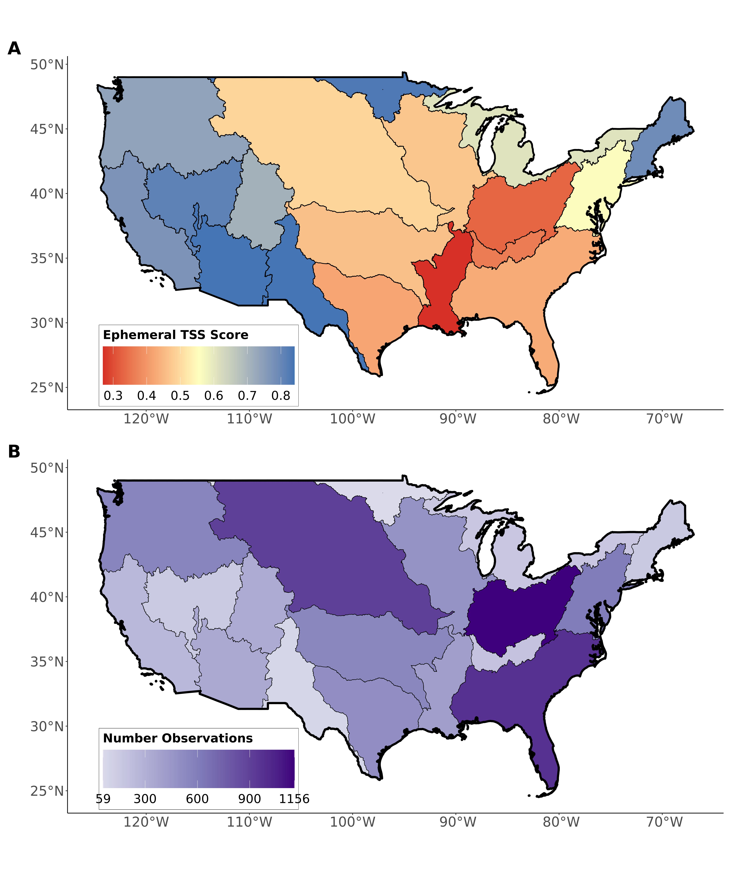

Fig. S1: Regional validations of the ephemeral stream classification model against completely independent field assessments of stream ephemerality: (A) regional model classification *TSS* and (B) number of field-observations per region. The average number of regional observations is 438.

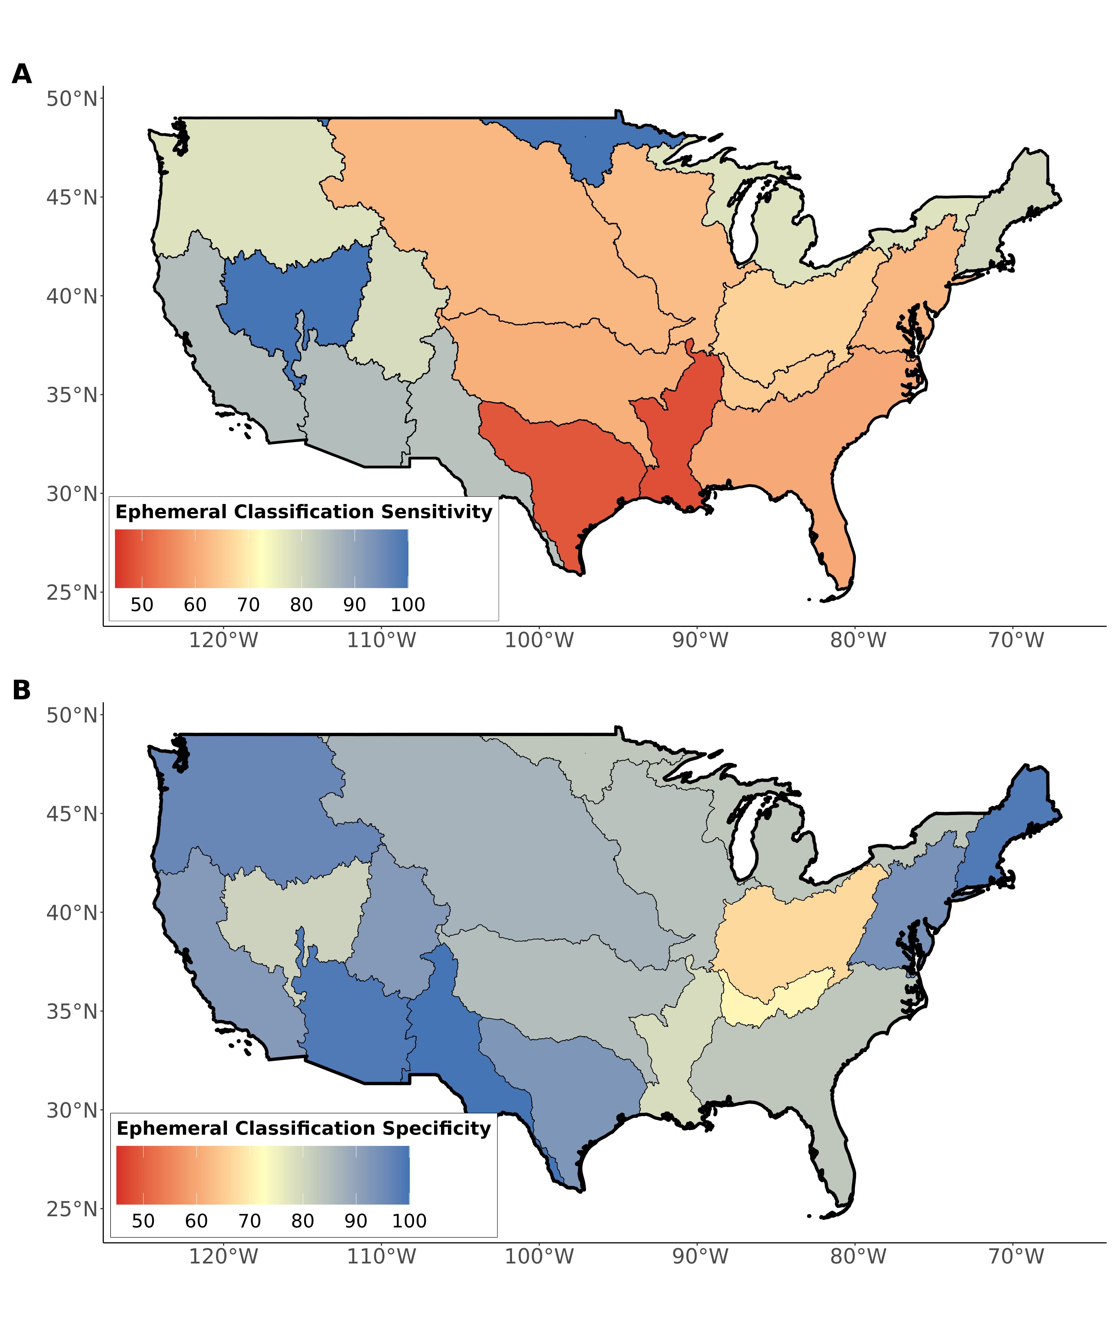

Fig. S2: Regional validations of the ephemeral stream classification model against completely independent field assessments of stream ephemerality: (A) regional model classification sensitivity and (B) specificity.

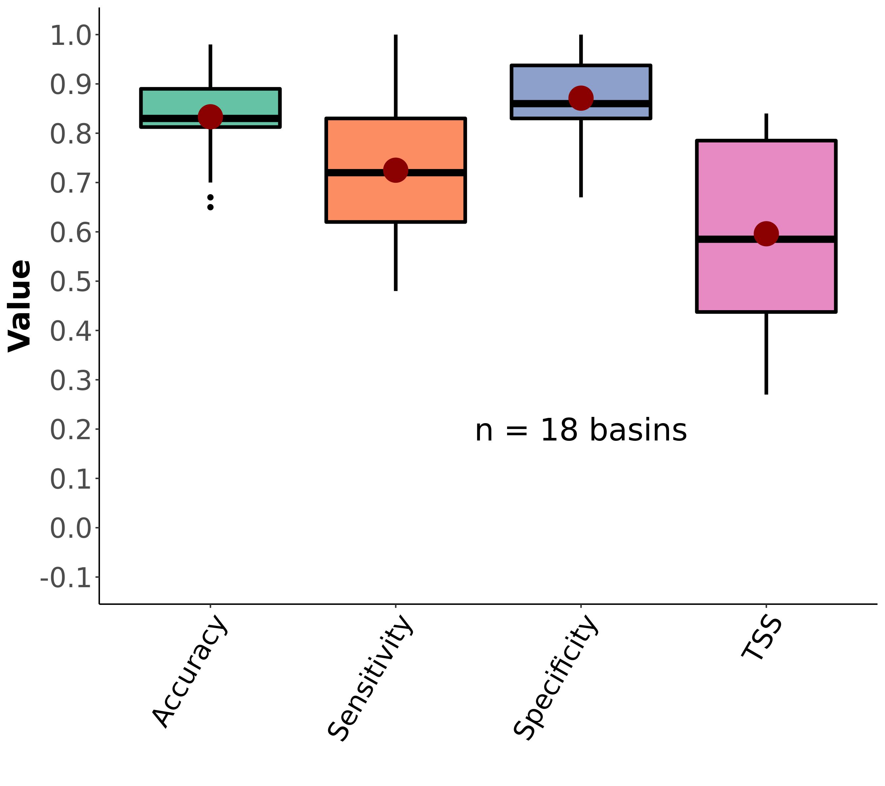

Fig. S3: Boxplots of regional ephemeral classification performance, by accuracy metric (section 3.2). Red dots correspond to the mean values. The outlier scores for sensitivity and TSS are from region HUC09 (Minnesota and Wisconsin draining to Canada). These poor scores are due to there only being 1 ephemeral stream in our dataset for that region. See Table S3 for metric definitions.

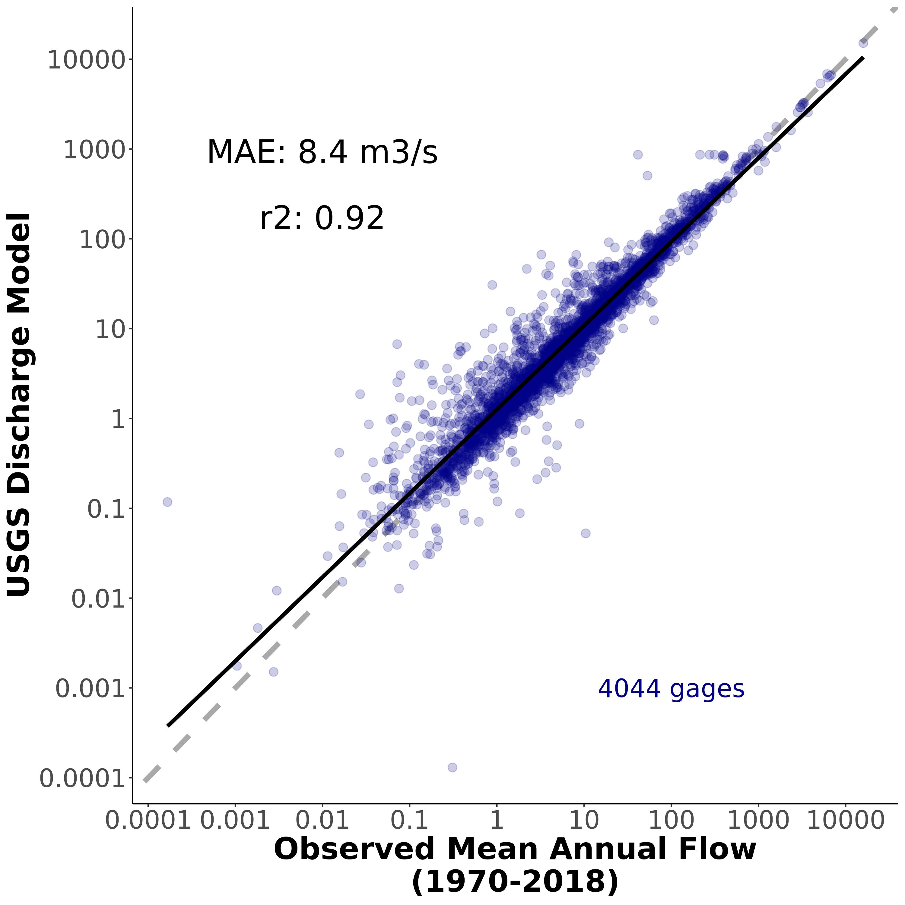

Fig. S4: Validation of discharge model at 4,044 streamgauges across CONUS.

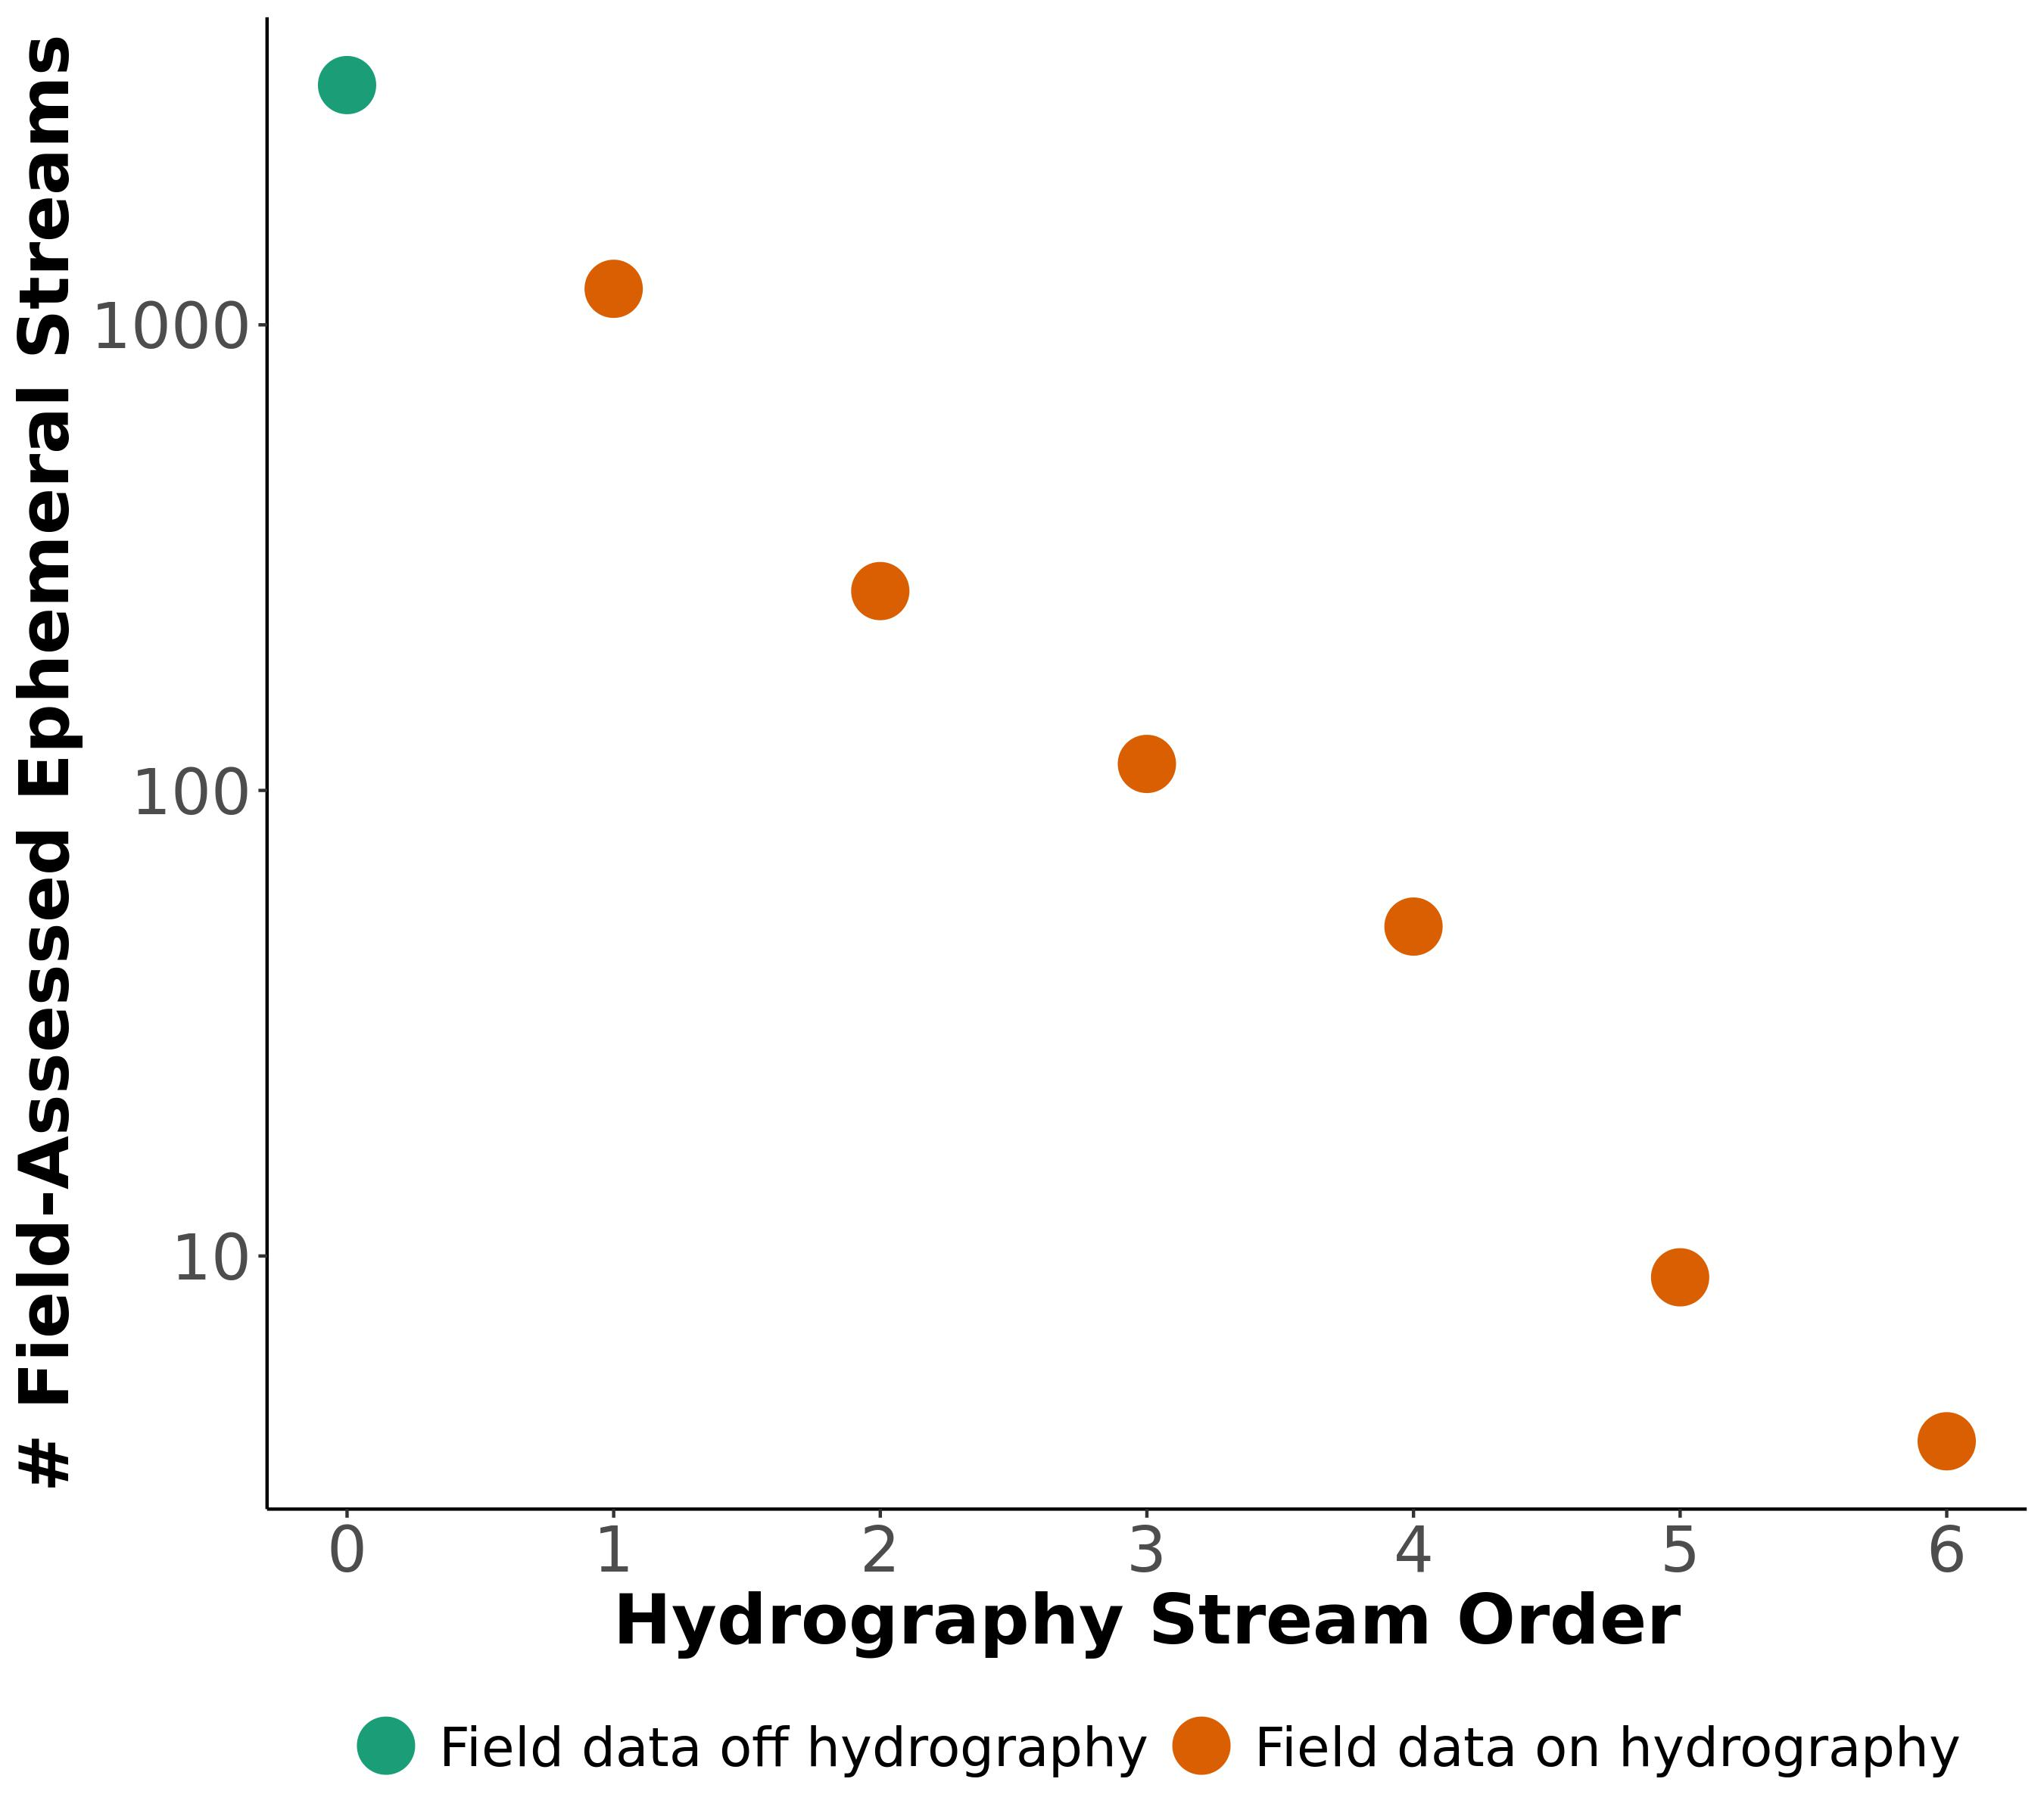

Fig. S5: Scaling model for CONUS ephemeral stream network. Orange points are associated with hydrography reaches while the green point is the number of ephemeral streams not associated with reaches and on streams too small to be included in the hydrography (using a 10m snapping threshold). 1 additional order is needed to ‘capture’ the green point and match this observed pattern in our data (See section 3.3, Fig. S5, FIg. S6).

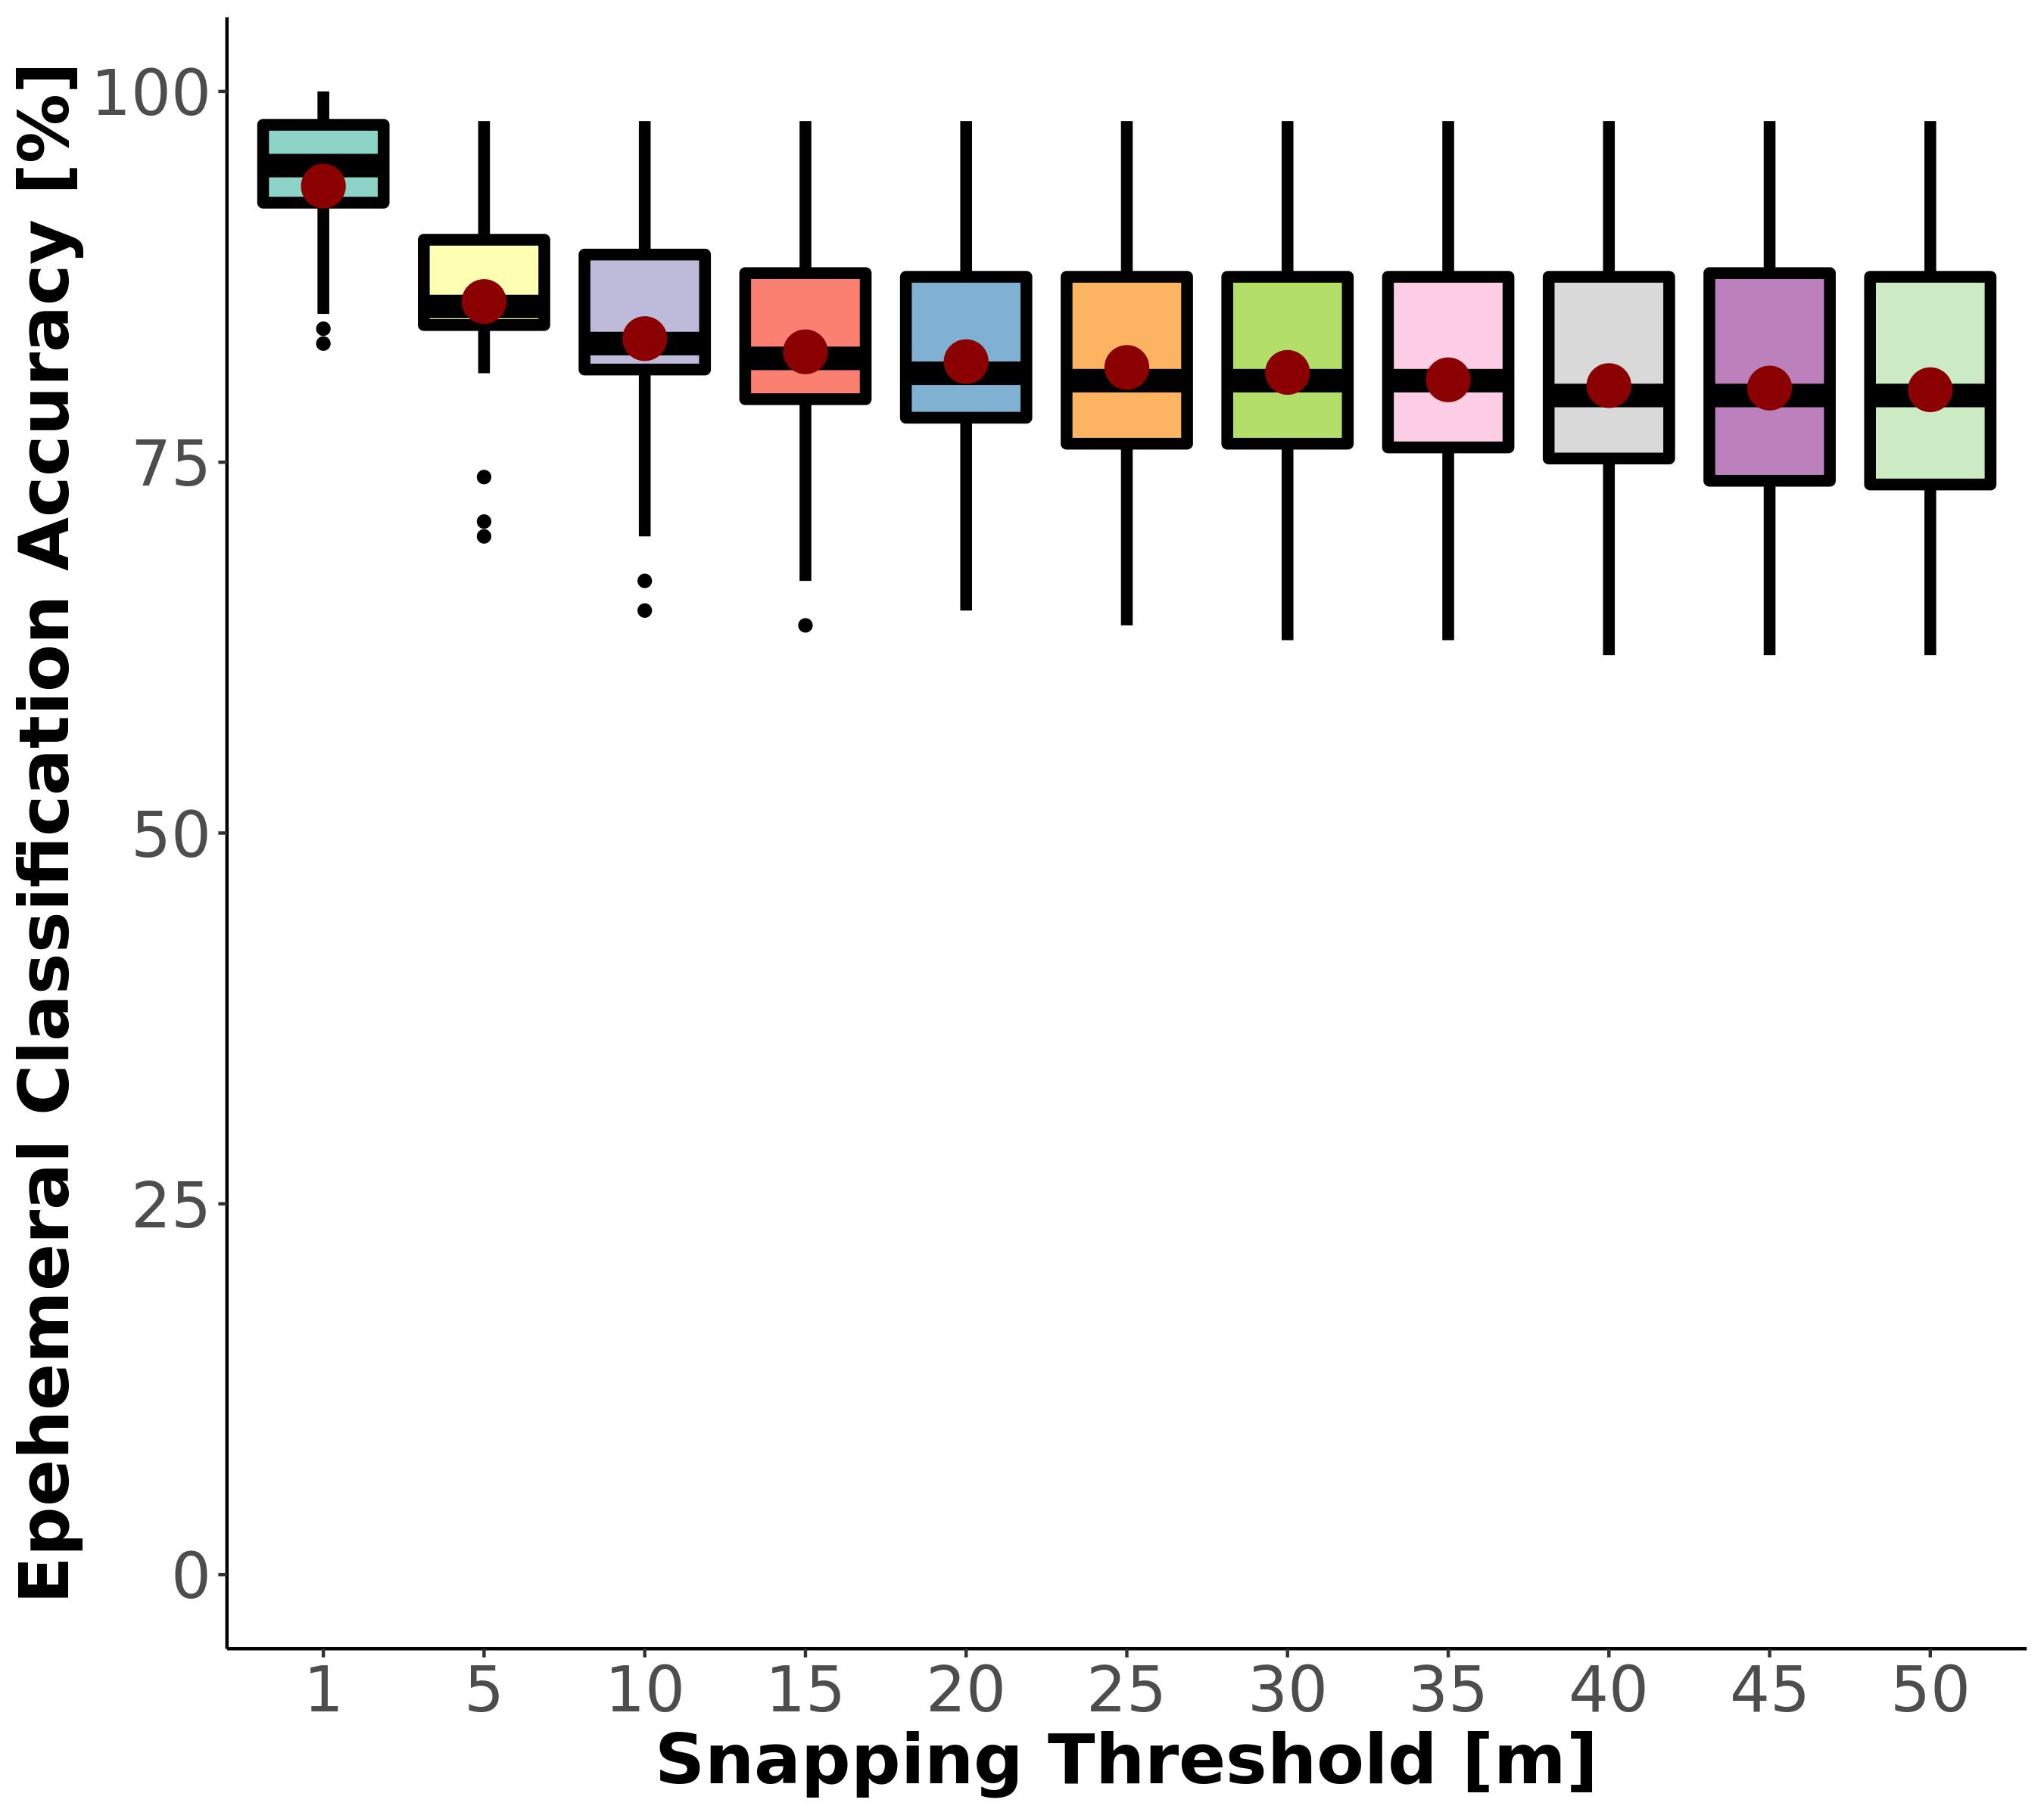

Fig. S6: Regional classification sensitivity to snapping threshold. Red points reflect the mean. Performance across the distributions (n=18 basins) is best (and normally distributed) at a snapping threshold of approximately 10-15m. A threshold of 1m yields artifically high classification performance because the threshold misses most small streams.

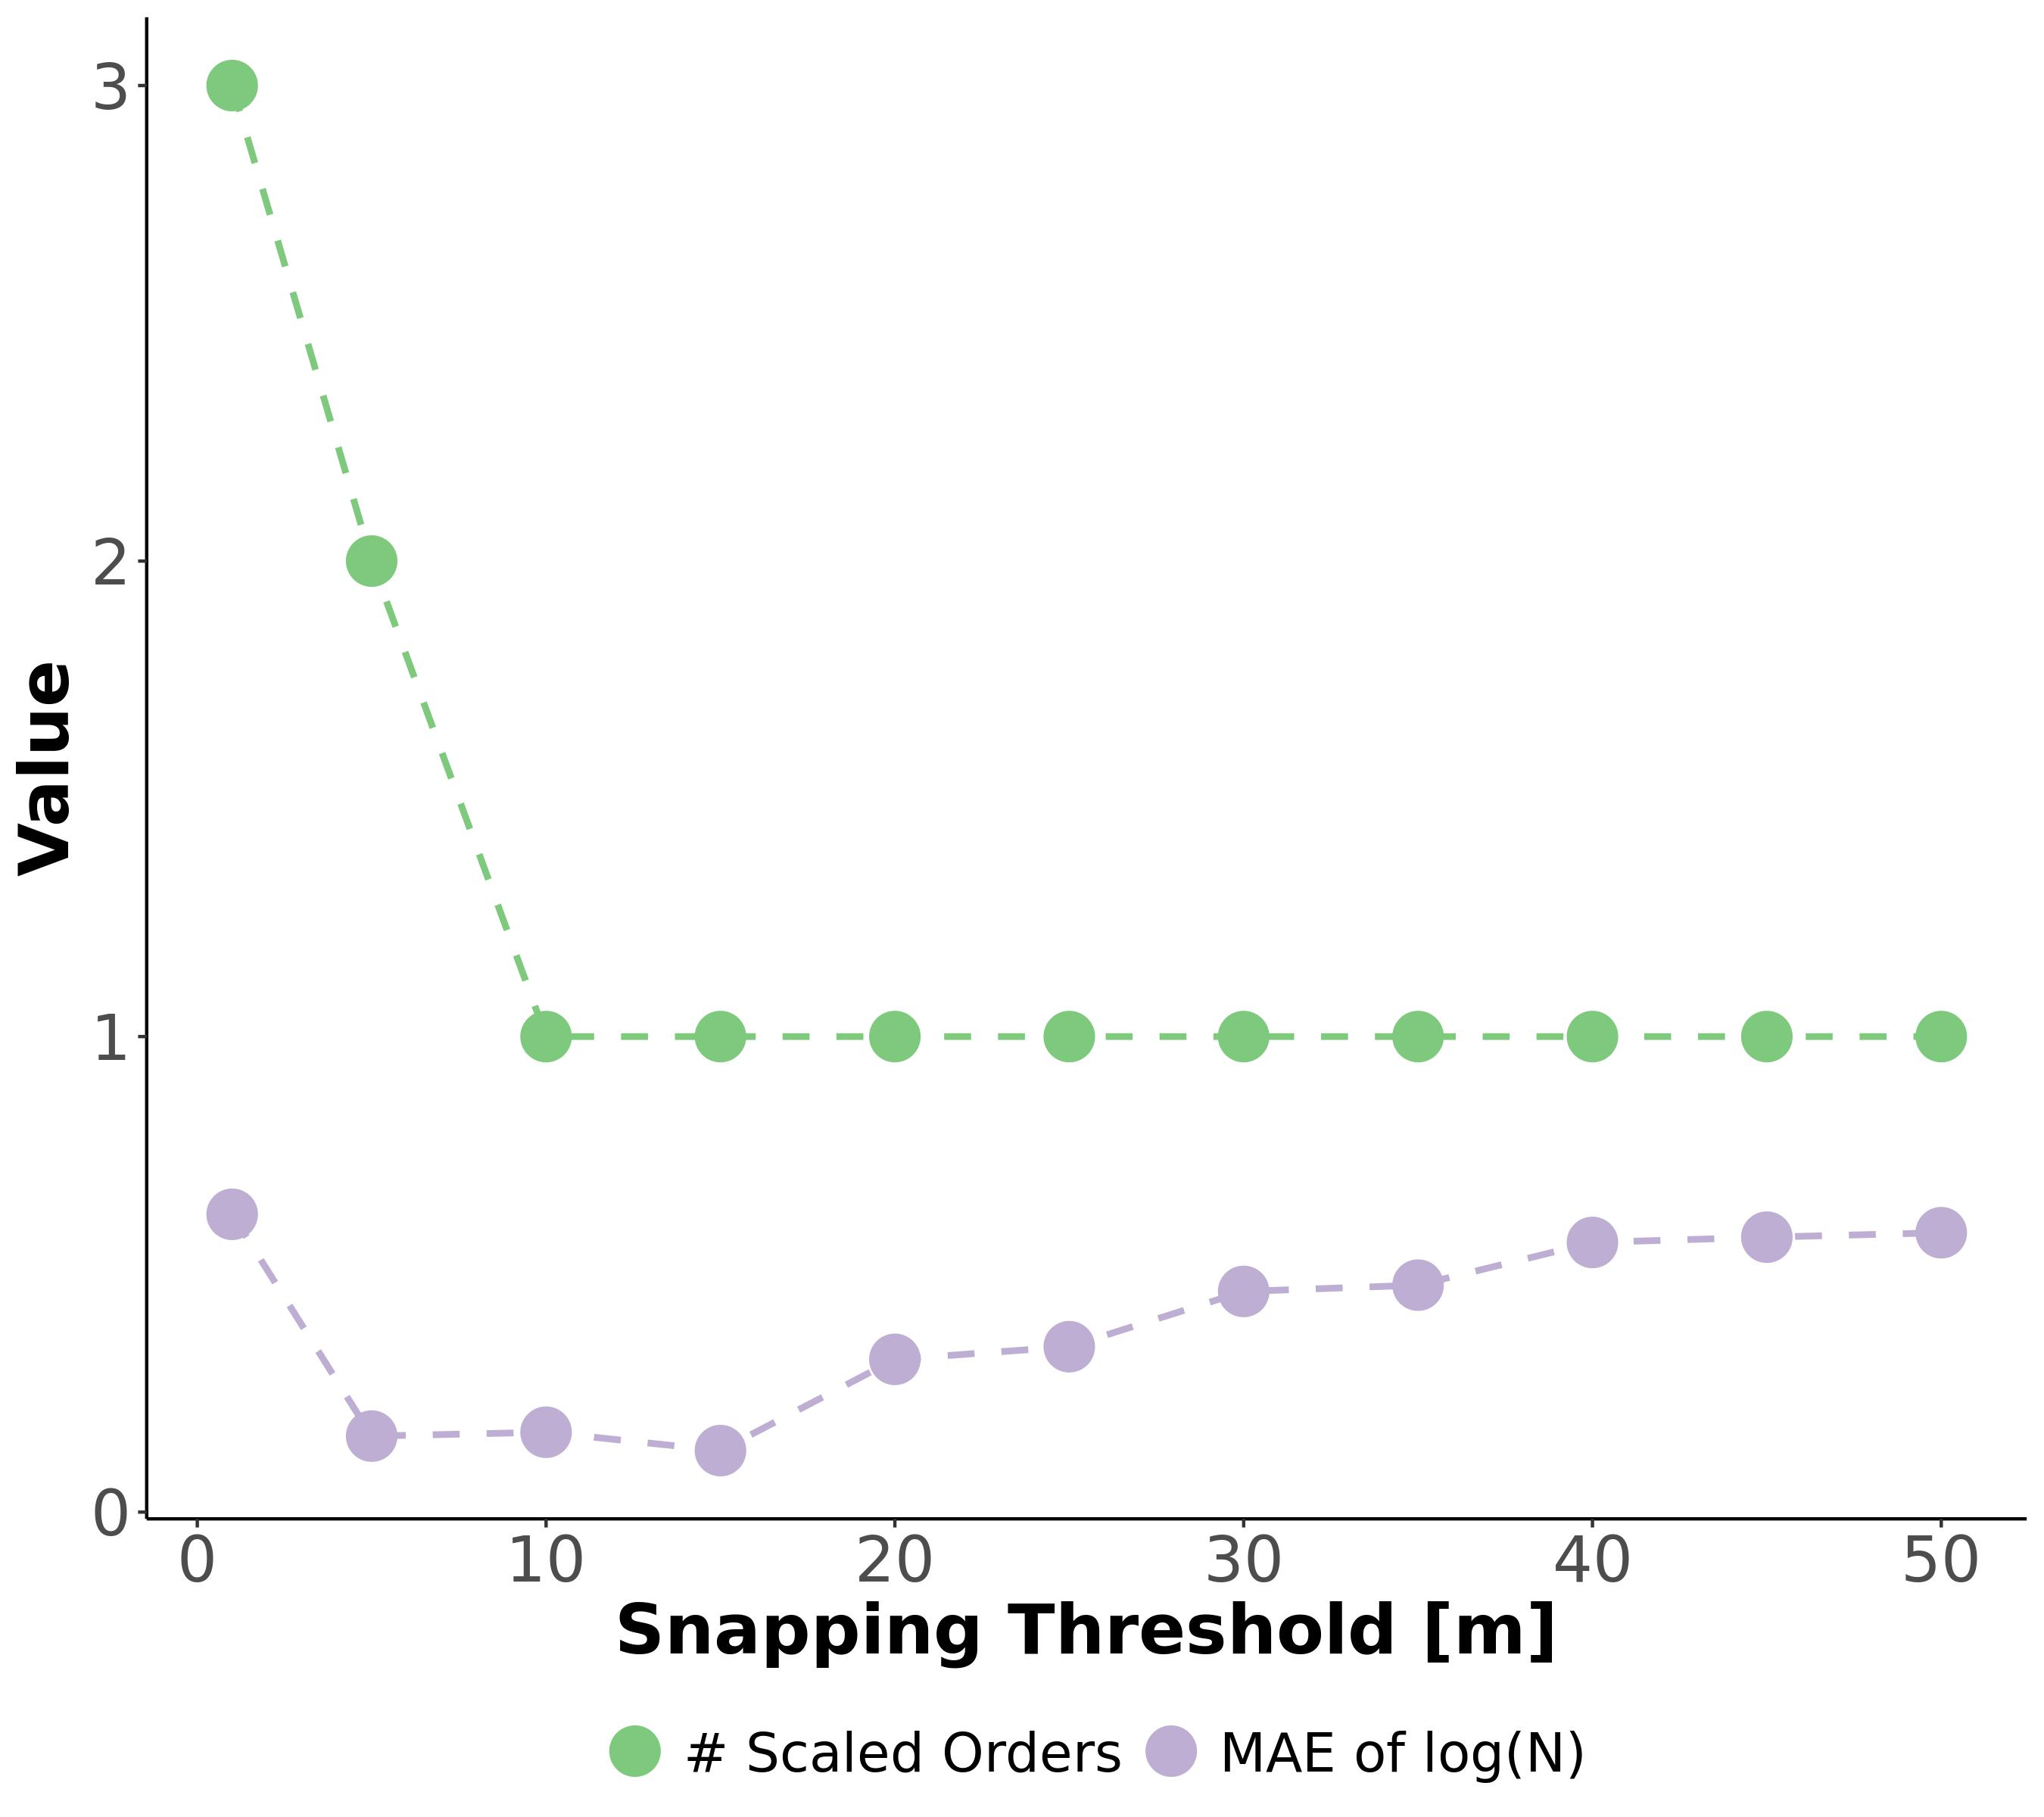

Fig. S7: Sensitivity test of the snapping threshold used to join field assessments of ephemerality to the drainage network. Green line is the number of additional stream orders calculated by equation S7, given a snapping threshold. Purple line is the mean absolute error (MAE) of the Horton law of stream numbers (equation S6), given a snapping threshold. MAE should be smallest when the data best fit Horton’s laws, indicating that we are not missassinging field data to the wrong rivers. This is explained in detail in sections 1.4 and 3.3.

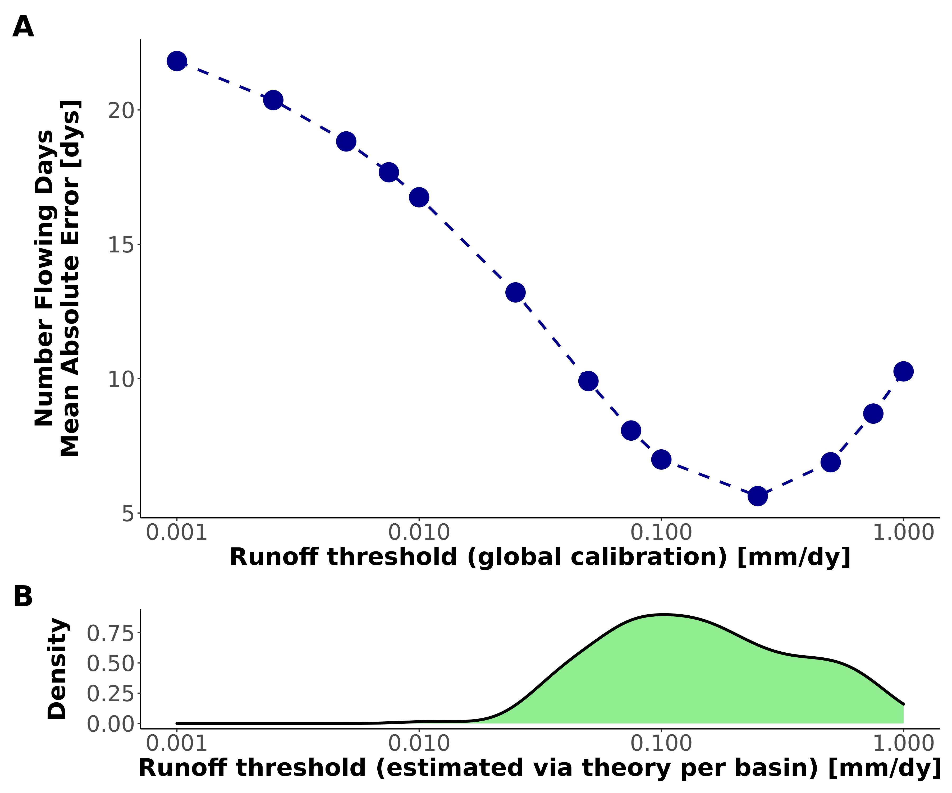

Fig. S8: Assessing our runoff threshold model ( $i_{min}$ via equation S10) by comparing it against a calibrated $i_{min}$ (section 5.2). (A) Global-scope calibration of $i_{min}$ to available $N_{flw}$ data (section 5.1). (B) CONUS distribution of basin $i_{min}$ calculated using equation S10. The latter model is the one used to generate the Fig. 2 results.

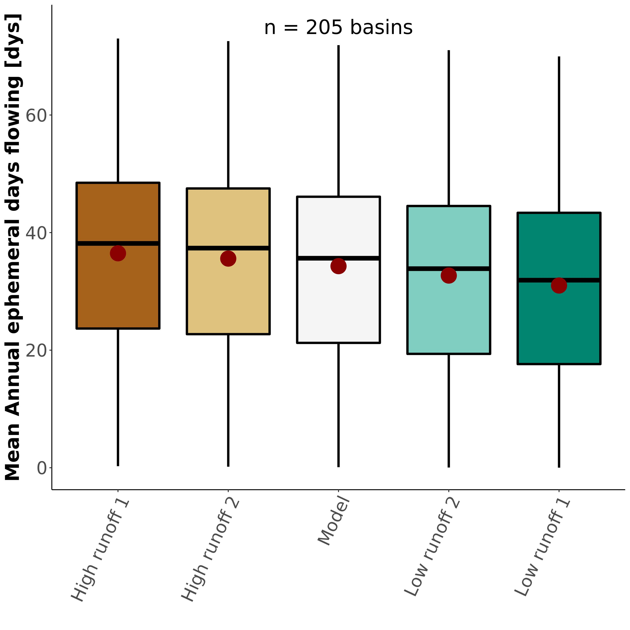

Fig. S9: Sensitivity test for $N_{flw}$ (section 5.2), resulting in boxplots of the basin-averaged, mean annual number of days that ephemeral streams flow (white boxplot is equivalent to Fig. 2a). Table S5 details the runoff scenarios used.



Fig. S10: Sample of 16/205 drainage network hydrographies classified using our model. Note that foreign streams are mapped as ‘not ephemeral’ in these plots for visualization’s sake (e.g. lower Colorado in sub-panel (D). Sub-plot titles refer to the raw and realtive ephemeral runoff contributions.

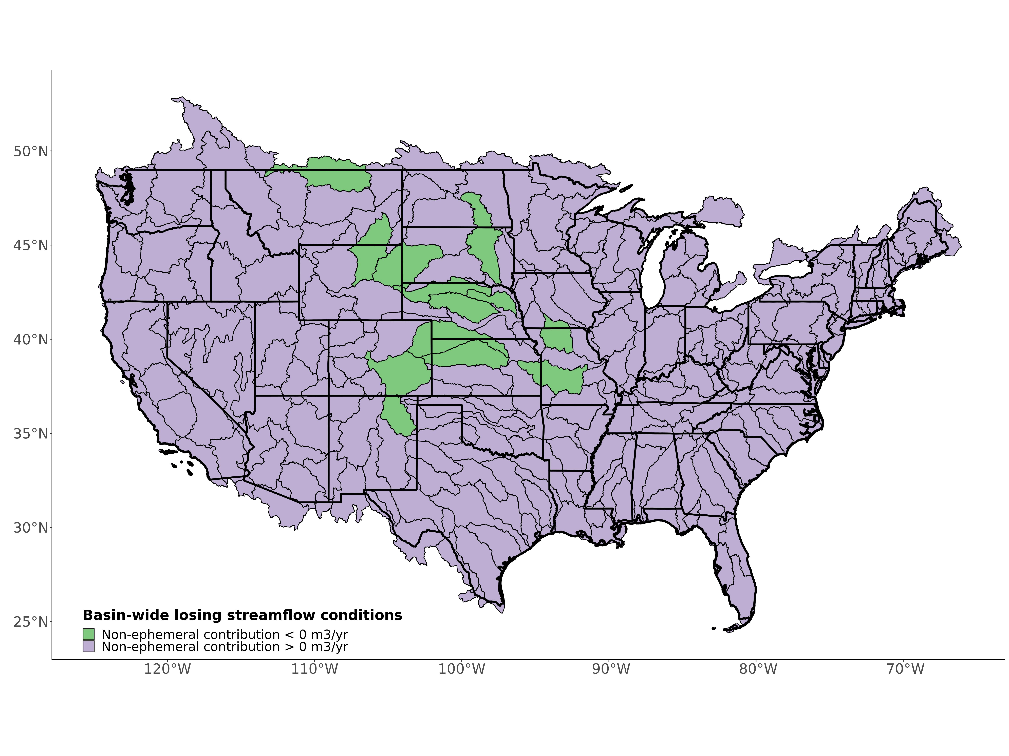

Fig. S11: Map of basins whose non-ephemeral runoff contribution is negative, indicating basin-wide losing conditions. While streamflow is lost in the these rivers, it is made up for in the ephemeral streams where runoff contributions greatly exceed the non-ephemeral runoff contribution (FIg. 1a).

## Supplementary Tables

**Table S1** Summary of models and geospatial data used to drive our model and generate our results. Point-based data used to validate is described in sections 1.4 and 5.1. See section 1.1 for details on the runoff data resolution, which exist at multipled nested levels.

| Variable | Dataset Name | Spatial Resolution | Temporal Resolution | Years caputred | Reference |
| --- | --- | --- | --- | --- | --- |
| Hydrography | USGS National Hydrography dataset (NHD) | 1:24,000 | - | Long-term | (*17*) |
| Discharge | USGS discharge model | 1:24,000 | Year | 1970-2000 | (*17*) |
| Water Table Depth | Fan Global Soil Hydrology Model | 30” | Month | 2004-2014 | (*16*); (*33*) |
| Land Cover | National Land Cover Dataset (NLCD) | 30” (downscaled from 1”) | Year | 2019 | (*20*) |
| Precipitation | CPC Unified Gauge-based Daily Precipitation Model | 0.25’ | Day | 1980-2010 | (*19*); (*54*) |
| Runoff | USGS runoff data | USGS level 4 basins | Year | 1970-2021 | (*18*) |

**Table S2** Field assessments of stream ephemerality performed in New England, Summer 2022. We followed the ephemeral/intermittent/perennial protocol for the State of North Carolina Department of Water Quality (*30*). Scores $<$ 19 are deemed ‘ephemeral’.

| Name | Latitude | Longitude | Score | Classification |
| --- | --- | --- | --- | --- |
| Tucker1 | 42.95125 | -71.07311 | 5.5 | ephemeral |
| Tucker2 | 42.94875 | -71.07479 | 15.0 | ephemeral |
| Atkins1 | 42.41396 | -72.46797 | 16.5 | ephemeral |
| Atkins2 | 42.42449 | -72.48076 | 8.0 | ephemeral |
| Harkness1 | 42.36701 | -72.47190 | 12.5 | ephemeral |

**Table S3:** Classification metrics used to assess the ephemeral mapping model. *TP* is the true positive rate, *TN* is the true negative rate, *FP* is the false positive rate, and *FN* is the false negative rate.

| Name | Definition |
| --- | --- |
| Accuracy | $\frac{N_{TP}+N_{TN}}{N_{TP}+N_{TN}+N_{FP}+N_{FN}}$ |
| Sensitivity | $\frac{N_{TP}}{N_{TP}+N_{FN}}$ |
| Specificity | $\frac{N_{TN}}{N_{TN}+N_{FP}}$ |
| True Skill Score (TSS) | Sensitivity + Specificity - 1 |

**Table S4:** In situ measurements of mean annual number of flowing days for ephemeral streams, compared against the same value calculated via our model (Fig. 2b). Uncertainty refers to 1 $σ$ from the Monte Carlo simulations (section 7).

|  | Model Basin | Model Nflw [dys] | Model Uncertainty [dys] | Watershed | Observed Nflw [dys] | Reference |
| --- | --- | --- | --- | --- | --- | --- |
| 33 | Neuse-Pamlico | 41 | 14 | Duke Forest | 59 | Zimmer & McGlynn, 2017 |
| 60 | Lake Ontario and Niagara Peninsula | 42 | 21 | Guelph | 57 | Peirce & Lindsay, 2015 |
| 187 | Lower Gila | 4 | 5 | Goldwater | 1 | Stromberg et al. 2017 |
| 190 | Middle Gila | 6 | 8 | Huachuca | 2 | Stromberg et al. 2017 |
| 188 | Lower Colorado | 12 | 6 | Mohave | 2 | Kampf et al. 2018 |
| 177 | Rio Grande-Elephant Butte | 11 | 12 | Montoyas | 1 | Schoener 2022 |
| 201 | Middle Snake | 40 | 15 | Reynolds Creek | 28 | Slaughter et al. 2001 |
| 78 | Kentucky-Licking | 54 | 13 | Robinson Forest | 50 | Fritz et al. 2019 |
| 190.1 | Middle Gila | 6 | 8 | Santa Rita | 10 | Moran et al. 2008 |
| 190.2 | Middle Gila | 6 | 8 | Walnut Gulch | 7 | Moran et al. 2008 |
| 188.1 | Lower Colorado | 12 | 6 | Yuma | 2 | Kampf et al. 2018 |

**Table S5:** Runoff scenarios used in the $N_{flw}$ sensitivity analysis. See section 5.2 for more specifics.

| Name | Runoff Memory | Runoff ratio ($i_{r}$) |
| --- | --- | --- |
| Low runoff 1 | 10 days | $i_{r}+0.33i_{r}$ |
| Low runoff 2 | 6 days | $i_{r}+0.18i_{r}$ |
| High runoff 1 | 0 days | $i_{r}−0.33i_{r}$ |
| High runoff 2 | 1 day | $i_{r}+0.18i_{r}$ |

## References

1. Department of the Army, Corps of Engineers, E. P. Agency, The Navigable Waters Protection Rule: Definition of “Waters of the United States.” *Federal Register* (2020).

2. P. A. Raymond, J. E. Saiers, W. V. Sobczak, [Hydrological and biogeochemical controls on watershed dissolved organic matter transport: Pulse-shunt concept](https://doi.org/10.1890/14-1684.1). *Ecology*. **97**, 5–16 (2016).

3. B. He, S. Kanae, T. Oki, Y. Hirabayashi, Y. Yamashiki, K. Takara, [Assessment of global nitrogen pollution in rivers using an integrated biogeochemical modeling framework](https://doi.org/10.1016/j.watres.2011.02.011). *Water Research*. **45**, 2573–2586 (2011).

4. C. Schmidt, T. Krauth, S. Wagner, [Export of Plastic Debris by Rivers into the Sea](https://doi.org/10.1021/acs.est.7b02368). *Environmental Science & Technology*. **51**, 12246–12253 (2017).

5. M. Liu, Q. Zhang, T. Maavara, S. Liu, X. Wang, P. A. Raymond, [Rivers as the largest source of mercury to coastal oceans worldwide](https://doi.org/10.1038/s41561-021-00793-2). *Nature Geoscience*. **14**, 672–677 (2021).

6. L. C. Alexander, K. M. Fritz, K. A. Schofield, B. C. Autrey, J. E. DeMeester, H. E. Golden, D. C. Goodrich, W. G. Kepner, H. R. Kiperwas, C. R. Lane, S. D. LeDuc, S. G. Leibowitz, M. G. McManus, A. I. Pollard, C. E. Ridley, M. K. Vanderhoof, P. J. Wigington Jr., [Featured Collection Introduction: Connectivity of Streams and Wetlands to Downstream Waters](https://doi.org/10.1111/1752-1688.12630). *JAWRA Journal of the American Water Resources Association*. **54**, 287–297 (2018).

7. J. Harvey, J. Gomez-Velez, N. Schmadel, D. Scott, E. Boyer, R. Alexander, K. Eng, H. Golden, A. Kettner, C. Konrad, R. Moore, J. Pizzuto, G. Schwarz, C. Soulsby, J. Choi, [How Hydrologic Connectivity Regulates Water Quality in River Corridors](https://doi.org/10.1111/1752-1688.12691). *JAWRA Journal of the American Water Resources Association*. **55**, 369–381 (2019).

8. D. A. Keiser, J. S. Shapiro, [Consequences of the Clean Water Act and the Demand for Water Quality*](https://doi.org/10.1093/qje/qjy019). *The Quarterly Journal of Economics*. **134**, 349–396 (2019).

9. S. M. P. Sullivan, M. C. Rains, A. D. Rodewald, W. W. Buzbee, A. D. Rosemond, [Distorting science, putting water at risk](https://doi.org/10.1126/science.abb6899). *Science*. **369**, 766–768 (2020).

10. M. L. Messager, B. Lehner, C. Cockburn, N. Lamouroux, H. Pella, T. Snelder, K. Tockner, T. Trautmann, C. Watt, T. Datry, [Global prevalence of non-perennial rivers and streams](https://doi.org/10.1038/s41586-021-03565-5). *Nature*. **594**, 391–397 (2021).

11. K. L. Jaeger, R. Sando, R. R. McShane, J. B. Dunham, D. P. Hockman-Wert, K. E. Kaiser, K. Hafen, J. C. Risley, K. W. Blasch, [Probability of Streamflow Permanence Model (PROSPER): A spatially continuous model of annual streamflow permanence throughout the Pacific Northwest](https://doi.org/10.1016/j.hydroa.2018.100005). *Journal of Hydrology X*. **2**, 100005 (2019).

12. N. Durighetto, V. Mariotto, F. Zanetti, K. J. McGuire, G. Mendicino, A. Senatore, G. Botter, [Probabilistic Description of Streamflow and Active Length Regimes in Rivers](https://doi.org/10.1029/2021WR031344). *Water Resources Research*. **58**, e2021WR031344 (2022).

13. P. P. Russell, S. M. Gale, B. Muñoz, J. R. Dorney, M. J. Rubino, [A Spatially Explicit Model for Mapping Headwater Streams](https://doi.org/10.1111/jawr.12250). *JAWRA Journal of the American Water Resources Association*. **51**, 226–239 (2015).

14. K. A. Fesenmyer, S. J. Wenger, D. S. Leigh, H. M. Neville, [Large portion of USA streams lose protection with new interpretation of Clean Water Act](https://doi.org/10.1086/713084). *Freshwater Science*. **40**, 252–258 (2021).

15. Materials and methods are available as supplementary materials at the Science website.

16. Y. Fan, G. Miguez-Macho, E. G. Jobbágy, R. B. Jackson, C. Otero-Casal, [Hydrologic regulation of plant rooting depth](https://doi.org/10.1073/pnas.1712381114). *Proceedings of the National Academy of Sciences*. **114**, 10572–10577 (2017).

17. U. S. G. Survey, National Hydrography Dataset (ver. USGS National Hydrography Dataset High Resolution(NHD-HR) for Hydrologic Unit (HU) 4 (2022).

18. J. w. Brakebill, D. m. Wolock, S. e. Terziotti, [Digital Hydrologic Networks Supporting Applications Related to Spatially Referenced Regression Modeling1](https://doi.org/10.1111/j.1752-1688.2011.00578.x). *JAWRA Journal of the American Water Resources Association*. **47**, 916–932 (2011).

19. P. Xie, M. Chen, S. Yang, A. Yatagai, T. Hayasaka, Y. Fukushima, C. Liu, [A Gauge-Based Analysis of Daily Precipitation over East Asia](https://doi.org/10.1175/JHM583.1). *Journal of Hydrometeorology*. **8**, 607–626 (2007).

20. J. Dewitz, National Land Cover Database (NLCD) 2019 Products (2021), doi:[10.5066/P9KZCM54](https://doi.org/10.5066/P9KZCM54).

21. D. Feng, C. J. Gleason, P. Lin, X. Yang, M. Pan, Y. Ishitsuka, [Recent changes to Arctic river discharge](https://doi.org/10.1038/s41467-021-27228-1). *Nature Communications*. **12**, 6917 (2021).

22. S. Jasechko, H. Seybold, D. Perrone, Y. Fan, J. W. Kirchner, [Widespread potential loss of streamflow into underlying aquifers across the USA](https://doi.org/10.1038/s41586-021-03311-x). *Nature*. **591**, 391–395 (2021).

23. L. E. Condon, R. M. Maxwell, [Evaluating the relationship between topography and groundwater using outputs from a continental-scale integrated hydrology model](https://doi.org/10.1002/2014WR016774). *Water Resources Research*. **51**, 6602–6621 (2015).

24. D. c. Goodrich, W. g. Kepner, L. r. Levick, P. j. Wigington Jr., [Southwestern Intermittent and Ephemeral Stream Connectivity](https://doi.org/10.1111/1752-1688.12636). *JAWRA Journal of the American Water Resources Association*. **54**, 400–422 (2018).

25. B. R. Scanlon, C. C. Faunt, L. Longuevergne, R. C. Reedy, W. M. Alley, V. L. McGuire, P. B. McMahon, [Groundwater depletion and sustainability of irrigation in the US High Plains and Central Valley](https://doi.org/10.1073/pnas.1200311109). *Proceedings of the National Academy of Sciences*. **109**, 9320–9325 (2012).

26. C. B. Brinkerhoff, P. A. Raymond, T. Maavara, Y. Ishitsuka, K. S. Aho, C. J. Gleason, [Lake Morphometry and River Network Controls on Evasion of Terrestrially Sourced Headwater CO2](https://doi.org/10.1029/2020GL090068). *Geophysical Research Letters*. **48**, e2020GL090068 (2021).

27. C. B. Brinkerhoff, C. J. Gleason, C. J. Zappa, P. A. Raymond, M. E. Harlan, [Remotely Sensing River Greenhouse Gas Exchange Velocity Using the SWOT Satellite](https://doi.org/10.1029/2022GB007419). *Global Biogeochemical Cycles*. **36**, e2022GB007419 (2022).

28. B. B. Cael, A. J. Heathcote, D. A. Seekell, [The volume and mean depth of Earth’s lakes](https://doi.org/10.1002/2016GL071378). *Geophysical Research Letters*. **44**, 209–218 (2017).

29. USEPA, CWA Approved JDs.

30. J. Dorney, P. Russell, "[Chapter 4.1.1 - North Carolina Division of Water Quality Methodology for Identification of Intermittent and Perennial Streams and Their Origins](https://doi.org/10.1016/B978-0-12-805091-0.00014-1)" in *Wetland and Stream Rapid Assessments*, J. Dorney, R. Savage, R. W. Tiner, P. Adamus, Eds. (Academic Press, 2018), pp. 273–279.

31. C. A. Krabbenhoft, G. H. Allen, P. Lin, S. E. Godsey, D. C. Allen, R. M. Burrows, A. G. DelVecchia, K. M. Fritz, M. Shanafield, A. J. Burgin, M. A. Zimmer, T. Datry, W. K. Dodds, C. N. Jones, M. C. Mims, C. Franklin, J. C. Hammond, S. Zipper, A. S. Ward, K. H. Costigan, H. E. Beck, J. D. Olden, [Assessing placement bias of the global river gauge network](https://doi.org/10.1038/s41893-022-00873-0). *Nature Sustainability*. **5**, 586–592 (2022).

32. M. A. Zimmer, K. E. Kaiser, J. R. Blaszczak, S. C. Zipper, J. C. Hammond, K. M. Fritz, K. H. Costigan, J. Hosen, S. E. Godsey, G. H. Allen, S. Kampf, R. M. Burrows, C. A. Krabbenhoft, W. Dodds, R. Hale, J. D. Olden, M. Shanafield, A. G. DelVecchia, A. S. Ward, M. C. Mims, T. Datry, M. T. Bogan, K. S. Boersma, M. H. Busch, C. N. Jones, A. J. Burgin, D. C. Allen, [Zero or not? Causes and consequences of zero-flow stream gage readings](https://doi.org/10.1002/wat2.1436). *WIREs Water*. **7**, e1436 (2020).

33. Y. Fan, H. Li, G. Miguez-Macho, [Global Patterns of Groundwater Table Depth](https://doi.org/10.1126/science.1229881). *Science*. **339**, 940–943 (2013).

34. L. E. Condon, S. Kollet, M. F. P. Bierkens, G. E. Fogg, R. M. Maxwell, M. C. Hill, H.-J. H. Fransen, A. Verhoef, A. F. Van Loon, M. Sulis, C. Abesser, [Global Groundwater Modeling and Monitoring: Opportunities and Challenges](https://doi.org/10.1029/2020WR029500). *Water Resources Research*. **57**, e2020WR029500 (2021).

35. I. E. M. de Graaf, E. H. Sutanudjaja, L. P. H. van Beek, M. F. P. Bierkens, [A high-resolution global-scale groundwater model](https://doi.org/10.5194/hess-19-823-2015). *Hydrology and Earth System Sciences*. **19**, 823–837 (2015).

36. O. Allouche, A. Tsoar, R. Kadmon, [Assessing the accuracy of species distribution models: Prevalence, kappa and the true skill statistic (TSS)](https://doi.org/10.1111/j.1365-2664.2006.01214.x). *Journal of Applied Ecology*. **43**, 1223–1232 (2006).

37. R. E. Horton, [EROSIONAL DEVELOPMENT OF STREAMS AND THEIR DRAINAGE BASINS; HYDROPHYSICAL APPROACH TO QUANTITATIVE MORPHOLOGY](https://doi.org/10.1130/0016-7606(1945)56[275:EDOSAT]2.0.CO;2). *GSA Bulletin*. **56**, 275–370 (1945).

38. J. W. Kirchner, [Statistical inevitability of Horton’s laws and the apparent randomness of stream channel networks](https://doi.org/10.1130/0091-7613(1993)021<0591:SIOHSL>2.3.CO;2). *Geology*. **21**, 591–594 (1993).

39. L. E. Milton, [The Geomorphic Irrelevance of Some Drainage Net Laws](https://doi.org/10.1111/j.1467-8470.1966.tb00055.x). *Australian Geographical Studies*. **4**, 89–95 (1966).

40. K. L. BOWDEN, J. R. WALLIS, [EFFECT OF STREAM-ORDERING TECHNIQUE ON HORTON’S LAWS OF DRAINAGE COMPOSITION](https://doi.org/10.1130/0016-7606(1964)75[767:EOSTOH]2.0.CO;2). *GSA Bulletin*. **75**, 767–774 (1964).

41. M. A. Zimmer, B. L. McGlynn, [Bidirectional streamgroundwater flow in response to ephemeral and intermittent streamflow and groundwater seasonality](https://doi.org/10.1002/hyp.11301). *Hydrological Processes*. **31**, 3871–3880 (2017).

42. K. M. Fritz, G. J. Pond, B. R. Johnson, C. D. Barton, [Coarse particulate organic matter dynamics in ephemeral tributaries of a Central Appalachian stream network](https://doi.org/10.1002/ecs2.2654). *Ecosphere*. **10**, e02654 (2019).

43. S. K. Kampf, J. Faulconer, J. R. Shaw, M. Lefsky, J. W. Wagenbrenner, D. J. Cooper, [Rainfall Thresholds for Flow Generation in Desert Ephemeral Streams](https://doi.org/10.1029/2018WR023714). *Water Resources Research*. **54**, 9935–9950 (2018).

44. C. W. Slaughter, D. Marks, G. N. Flerchinger, S. S. Van Vactor, M. Burgess, [Thirty-five years of research data collection at the Reynolds Creek Experimental Watershed, Idaho, United States](https://doi.org/10.1029/2001WR000413). *Water Resources Research*. **37**, 2819–2823 (2001).

45. M. S. Moran, C. D. Holifield Collins, D. C. Goodrich, J. Qi, D. T. Shannon, A. Olsson, Long-term remote sensing database, Walnut Gulch Experimental Watershed, Arizona, United States. *Water Resources Research*. **44** (2008), doi:[10.1029/2006WR005689](https://doi.org/10.1029/2006WR005689).

46. G. Schoener, [Impact of urbanization and stormwater infrastructure on ephemeral channel transmission loss in a semiarid watershed](https://doi.org/10.1016/j.ejrh.2022.101089). *Journal of Hydrology: Regional Studies*. **41**, 101089 (2022).

47. J. C. Stromberg, D. L. Setaro, E. L. Gallo, K. A. Lohse, T. Meixner, [Riparian vegetation of ephemeral streams](https://doi.org/10.1016/j.jaridenv.2016.12.004). *Journal of Arid Environments*. **138**, 27–37 (2017).

48. S. E. Peirce, J. B. Lindsay, [Characterizing ephemeral streams in a southern Ontario watershed using electrical resistance sensors](https://doi.org/10.1002/hyp.10136). *Hydrological Processes*. **29**, 103–111 (2015).

49. K. M. Fritz, S. Fulton, B. R. Johnson, C. D. Barton, J. D. Jack, D. A. Word, R. A. Burke, [Structural and functional characteristics of natural and constructed channels draining a reclaimed mountaintop removal and valley fill coal mine](https://doi.org/10.1899/09-060.1). *Journal of the North American Benthological Society*. **29**, 673–689 (2010).

50. T. C. Winter, *Ground Water and Surface Water: A Single Resource* (DIANE Publishing, 1999).

51. M. A. Zimmer, B. L. McGlynn, [Lateral, Vertical, and Longitudinal Source Area Connectivity Drive Runoff and Carbon Export Across Watershed Scales](https://doi.org/10.1002/2017WR021718). *Water Resources Research*. **54**, 1576–1598 (2018).

52. G. H. Allen, T. M. Pavelsky, E. A. Barefoot, M. P. Lamb, D. Butman, A. Tashie, C. J. Gleason, [Similarity of stream width distributions across headwater systems](https://doi.org/10.1038/s41467-018-02991-w). *Nature Communications*. **9**, 610 (2018).

53. E. Moges, B. L. Ruddell, L. Zhang, J. M. Driscoll, L. G. Larsen, [Strength and Memory of Precipitation’s Control Over Streamflow Across the Conterminous United States](https://doi.org/10.1029/2021WR030186). *Water Resources Research*. **58**, e2021WR030186 (2022).

54. M. Chen, W. Shi, P. Xie, V. B. S. Silva, V. E. Kousky, R. Wayne Higgins, J. E. Janowiak, Assessing objective techniques for gauge-based analyses of global daily precipitation. *Journal of Geophysical Research: Atmospheres*. **113** (2008), doi:[10.1029/2007JD009132](https://doi.org/10.1029/2007JD009132).